BOOKS

**8 best world food writing books: Discover new destinations and dishes from your kitchen table**

The pages are filled with tastes and tales from the heights of the Himalayas to the Baltic states

[**Susan Low**](https://www.independent.co.uk/author/susan-low)

Monday 24 October 2022 17:14

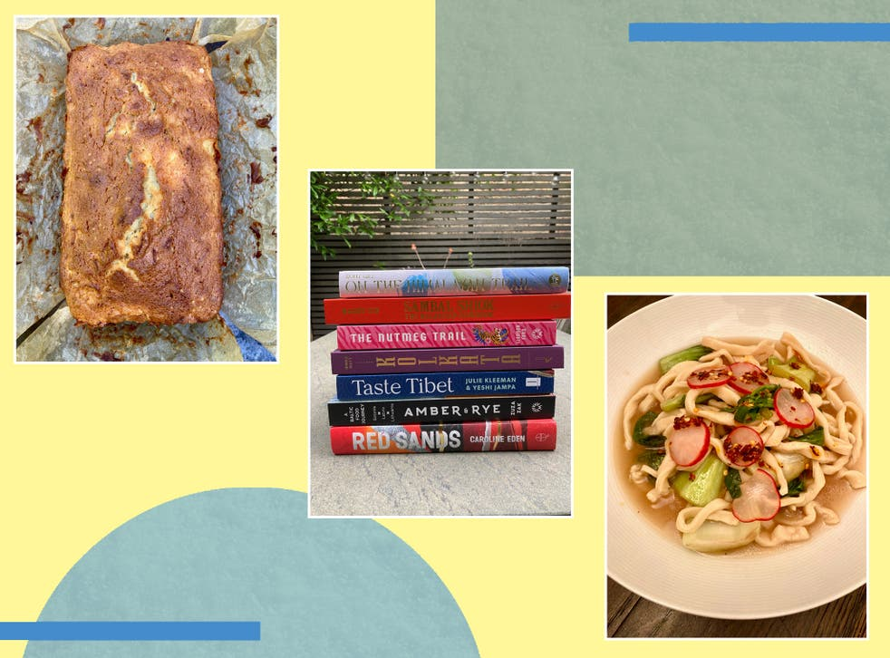

We rated these on their ability to introduce us to less-familiar food culture

*(The Independent)*

Post-Covid, [travel](https://www.independent.co.uk/travel) is back on the agenda. The latest figures from the IATA show that [global air traffic had recovered to 73 per cent of pre-crisis levels](https://eur02.safelinks.protection.outlook.com/?url=https%3A%2F%2Fwww.iata.org%2Fen%2Fpressroom%2F2022-releases%2F2022-10-06-02%2F&data=05%7C01%7Cindybest%40independent.co.uk%7C6db025e31a804128a65a08dab357212b%7C0f3a4c644dc54a768d4152d85ca158a5%7C0%7C0%7C638019484049473605%7CUnknown%7CTWFpbGZsb3d8eyJWIjoiMC4wLjAwMDAiLCJQIjoiV2luMzIiLCJBTiI6Ik1haWwiLCJXVCI6Mn0%3D%7C3000%7C%7C%7C&sdata=jwblB5ezZxS9Y49qhJ7JHUZENHPs1UTbc7t2ODKI%2FX0%3D&reserved=0) – but for anyone who sought to sate their wanderlust by taking to the skies this summer, the experience may have been a painful one...

Airport chaos, mile-long queues (that’s if your flight wasn’t cancelled), the Russian roulette of lost [baggage](https://www.independent.co.uk/extras/indybest/travel-outdoors/luggage/best-suitcases-b2073105.html), it’s understandable why not everyone is ready to squeeze themselves into an economy seat quite yet. But there is a way to get a taste of far-flung places without having to leave the warmth of your [kitchen](https://www.independent.co.uk/extras/indybest/house-garden/kitchen-appliances).

During the pandemic, the kitchen was a place of safety and sustenance, away from the doom loop of the pandemic. The great stay-at-home encouraged people to get creative with the contents of their kitchen, to venture beyond the microwave and the “ready in 15 minutes” recipes; to slow down and enjoy spending more time cooking.

So as people sought escapism and inspiration, sales of novels and cookbooks [soared during the pandemic](https://eur02.safelinks.protection.outlook.com/?url=https%3A%2F%2Fwww.reuters.com%2Fbusiness%2Fpublisher-bloomsbury-sets-special-dividend-lockdown-reading-boosts-earnings-2021-06-02%2F&data=05%7C01%7Cindybest%40independent.co.uk%7C6db025e31a804128a65a08dab357212b%7C0f3a4c644dc54a768d4152d85ca158a5%7C0%7C0%7C638019484049473605%7CUnknown%7CTWFpbGZsb3d8eyJWIjoiMC4wLjAwMDAiLCJQIjoiV2luMzIiLCJBTiI6Ik1haWwiLCJXVCI6Mn0%3D%7C3000%7C%7C%7C&sdata=YdE3028CsCHpq9F415kQ08goCZJPEd6nERQxA7z%2Ff1Q%3D&reserved=0). As a result, a new [cookbook](https://www.independent.co.uk/extras/indybest/books/cookbooks/best-cookbooks-learn-how-to-cook-beginner-jamie-oliver-mary-berry-a9487901.html) trend has emerged – a book that can whisk you away from it all and immerse you in an entirely different (and possibly new) food culture.

## How we tested

We rated the books on their ability to take readers on an edible journey and to introduce them to less-familiar food culture and cuisine. We also considered the quality of the prose (we were after books that were a good, solid read), the level of research undertaken and the quality of the photography, as well as the recipes: their “interestingness”, how well they worked and how much we enjoyed eating them.

These cookbooks, written or published during or since the pandemic are far more than collections of recipes. They take you away from it all and deliver you, metaphorically, to the Himalayas, the Baltic states, from Malaysia to Romania. They will tell leave you better informed about the world – and they will teach you some new delicious kitchen tricks, too.

## The best culinary escape books for 2022 are:

* **Best overall culinary escape book** – ‘Red Sands’ by Caroline Eden, published by Quadrille: £18.55, [Hive.co.uk](https://track.webgains.com/click.html?wgcampaignid=165253&wgprogramid=10671&wgtarget=https://www.hive.co.uk/Product/Caroline-Eden/Red-Sands--Reportage-and-Recipes-Through-Central-Asia-fro/24902787&clickref=xid:fr1668309677072hae)
* **Best culinary escape book for fermentation fans**– ‘Amber & Rye: A Baltic Food Journey’ by Zuza Zak, published by Murdoch: £18.55, [Hive.co.uk](https://track.webgains.com/click.html?wgcampaignid=165253&wgprogramid=10671&wgtarget=https://www.hive.co.uk/Product/Zuza-Zak/Amber--Rye--A-Baltic-food-journey-Estonia-Latvia-Lithuania/25534720&clickref=xid:fr1668309677072gbe)
* **Best culinary escape book for spice lovers**– ‘The Nutmeg Trail’ by Eleanor Ford, published by Murdoch: £20.66, [Wordery.com](https://www.awin1.com/awclick.php?mid=9111&id=201309&p=https://wordery.com/the-nutmeg-trail-eleanor-ford-9781922351531&clickref=xid:fr1668309677072ebf)
* **Best culinary escape book for new discoveries** – ‘Taste Tibet’ by Julie Kleeman, published by Murdoch: £20, [Blackwells.co.uk](https://blackwells.co.uk/bookshop/product/Taste-Tibet-by-Julie-Kleeman-Yeshi-Jampa/9781911668428)
* **Best culinary escape book for Indian food lovers** – ‘Kolkata The Cookbook’ by Rinku Dutt, published by Smith Street Books: £21, [Amazon.co.uk](http://buy.geni.us/Proxy.ashx?tsid=3658&GR_URL=https%3A%2F%2Fwww.amazon.co.uk%2FKolkata-Recipes-Bengal-Rinku-Dutt%2Fdp%2F1922417920%3Fascsubtag%3DIN%7C2207701%7C1922417920%23isAffiliate)
* **Best culinary escape book for Laksa lovers**– ‘Sambal Shiok’ by Mandy Yin, published by Quadrille: £20, [Blackwells.co.uk](https://blackwells.co.uk/bookshop/product/9781787137042)
* **Best culinary escape book for baking fans** – ‘Tava: Eastern European Baking and Desserts from Romania and Beyond’ by Irina Georgescu, published by Hardie Grant: £17.59, [Hive.co.uk](https://track.webgains.com/click.html?wgcampaignid=165253&wgprogramid=10671&wgtarget=https://www.hive.co.uk/Product/Irina-Georgescu/Tava--Eastern-European-Baking-and-Desserts-From-Romania--Beyond/27367341&clickref=xid:fr1668309677072jbc)
* **Best culinary escape book for travel trailblazers** – ‘On the Himalayan Trail: Recipes and Stories from Kashmir to Ladakh’ by Romy Gill, published by Hardie Grant: £20.65, [Wordery.com](https://www.awin1.com/awclick.php?mid=9111&id=201309&p=https://wordery.com/on-the-himalayan-trail-romy-gill-9781784884406&clickref=xid:fr1668309677072egj)

# 9 best horror books to read for Halloween (if you dare)

From bone-chilling thrillers to grisly tales, you’ll be sleeping with the light on by the end of these

[**Olivia Campbell**](https://www.independent.co.uk/author/olivia-campbell)

Thursday 20 October 2022 13:01

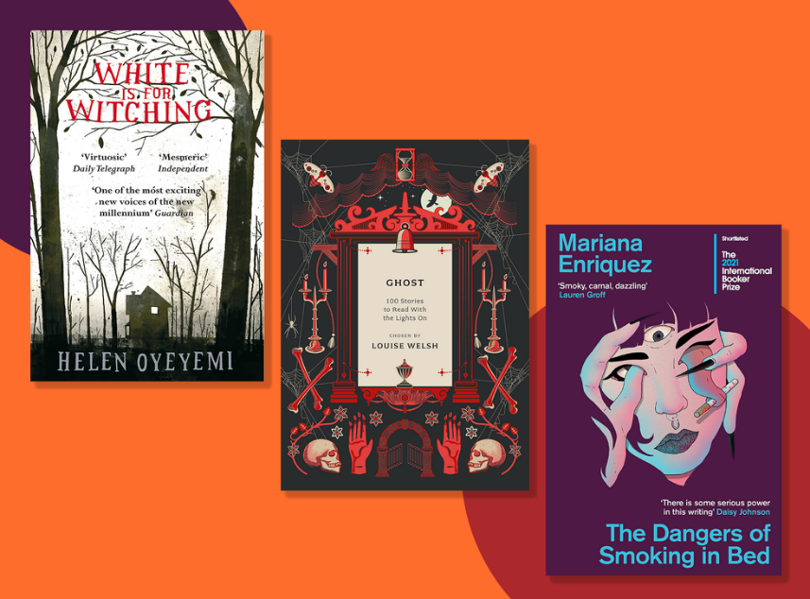

We looked for stories that left us with a sense of unease after reading – in a good way, of course*(The Independent)*

Since ancient times, people have been scaring the living daylights out of each other with tales of horror and the supernatural.

From tormented spirits to soul-eating demons and everything in between, nearly every culture to have existed has tales designed to spark fear in the hearts of its people.

With this in mind, and the fact that the [spooky season](https://www.independent.co.uk/extras/indybest/fashion-beauty/cheap-halloween-costumes-b2177296.html)is nearly upon us, now is the perfect time to pick up a book that will make the hair on the back of your neck stand up. To help, we’ve reviewed some of the most chilling tomes to have come from the horror genre.

Our list is by no means exhaustive – there are thousands of excellent novels spanning all sorts of themes and genres (techno-horror or femslash anyone?). There is also plenty of debate about what can be classified as “horror”.

For our purposes, all but one of the [books](https://www.independent.co.uk/extras/indybest/books?CMP=ILC-refresh) we’ve chosen have some element of the supernatural, whether that be ghosts or witchcraft. We’ve also tried to include books from across the spectrum, to appeal to as many readers as possible. Basically, if the book gave us the creeps, we’ve considered it.

## **How we tested**

Not all horror books are created equal. We’ve flipped through many pages to find books that didn’t rely on tropes and lazy storytelling to do the job, while also keeping us engaged with the plot throughout. But most importantly, we looked for stories we found truly scary, that left us with a sense of unease after reading – in a good way, of course!

## The best horror books for 2022 are:

* **Best overall horror book** − ‘The Silent Companions’ by Laura Purcell, published by Raven Books: £7.64,[Amazon.co.uk](http://buy.geni.us/Proxy.ashx?tsid=3658&GR_URL=https%3A%2F%2Fwww.amazon.co.uk%2FSilent-Companions-Ghost-Story%2Fdp%2F1408888033%2F%3Fascsubtag%3DIN%7C1932473%7C1408888033%23isAffiliate)
* **Best haunted-house horror book** − ‘White is For Witching’ by Helen Oyeyemi, published by Picador: £9.99,[Waterstones.com](https://www.awin1.com/awclick.php?mid=3787&id=201309&p=https://www.waterstones.com/book/white-is-for-witching/helen-oyeyemi/9780330458153&clickref=xid:fr1668309915857bgb)
* **Best graphic novel horror book** − ‘Uzumaki’ by Junji Ito, published by Viz Media Inc: £15.86, [Forbiddenplanet.com](https://forbiddenplanet.com/111616-uzumaki-3-in-1-deluxe/)
* **Best urban horror book** − ‘The Dangers of Smoking in Bed’ by Mariana Enriquez, published by Granta Books: £8.99,[Waterstones.com](https://www.awin1.com/awclick.php?mid=3787&id=201309&p=https://www.waterstones.com/book/the-dangers-of-smoking-in-bed/mariana-enriquez/megan-mcdowell/9781783788217&clickref=xid:fr1668309915857hca)
* **Best gothic horror book** − ‘The Picture of Dorian Gray’ (Penguin Clothbound Classics) by Oscar Wilde, published by Penguin Classics: £13.79,[WHSmith.co.uk](https://www.awin1.com/awclick.php?mid=3017&id=201309&p=https://www.whsmith.co.uk/products/the-picture-of-dorian-gray/oscar-wilde/robert-mighall/hardback/9780141442464.html&clickref=xid:fr1668309915857bfg)
* **Best children’s horror book** − ‘Coraline’ by Neil Gaiman, published by Bloomsbury Publishing:£7.99, [Waterstones.com](https://www.awin1.com/awclick.php?mid=3787&id=201309&p=https://www.waterstones.com/book/coraline/neil-gaiman/dave-mckean/9780747562108&clickref=xid:fr1668309915857bhj)
* **Best dark fantasy horror book** − ‘Something Wicked This Way Comes’ by Ray Bradbury, published by Orion Publishing: £8.99,[Waterstones.com](https://www.awin1.com/awclick.php?mid=3787&id=201309&p=https://www.waterstones.com/book/something-wicked-this-way-comes/ray-bradbury/9781473230583&clickref=xid:fr1668309915857edh)
* **Best for ghost stories** − ‘Ghost’ edited by Louise Welsh, published by Head of Zeus: £14.95, [Amazon.co.uk](http://buy.geni.us/Proxy.ashx?tsid=3658&GR_URL=https%3A%2F%2Fwww.amazon.co.uk%2FGhost-100-Stories-Read-Lights%2Fdp%2F1800249675%2F%3Fascsubtag%3DIN%7C1932473%7C1800249675%23isAffiliate)
* **Best classic horror book** − ‘We Have Always Lived in the Castle’ by Shirley Jackson, published by Penguin Classics: £7.99,[Blackwells.co.uk](https://blackwells.co.uk/bookshop/product/9780141191454)

# Kurt Vonnegut would have turned 100 today — his war novels are relevant as ever

An art installation commemorates the novel *Slaughterhouse-Five* in the cellar of the former slaughterhouse where author Kurt Vonnegut, then an American prisoner of war, was held in Dresden, Germany.

*Sean Gallup/Getty Images*

Kurt Vonnegut was disappointed in America. "I'm sorry that America isn't a greater success than it is," he told me in 1991. "Because we're so wealthy and we really could have done almost anything. And we've done so very little in comparison to what we might have done in creating an ideal society."

Vonnegut, who died in 2007 at the age of 84, would have turned 100 today. He was born in Indianapolis on Nov. 11, 1922, [Armistice Day](https://www.loc.gov/item/today-in-history/november-11/). The late author wrote satirical and darkly humorous novels that won him a cult-like following with the youth culture of the 1960s — but his work remains relevant today.

Vonnegut wrote novels about the irrationality of governments and the senseless destruction of war. His work was informed by his experience in World War II when he was a 22-year-old soldier captured by the Germans in the Battle of the Bulge.

In 1987, he told me he was determined to write about war without romanticizing it. "My own feeling is that Civilization ended in World War I, and we're still trying to recover from that," he said. "Much of the blame is the malarkey that artists have created to glorify war — romantic pictures of battle, and of the dead and men in uniform and all that. And I did not want to have that story told again."

Four years later, shortly after the first Gulf War, Vonnegut was saddened by what he saw in America. "We have become such a pitiless people," he said. "And I think it's TV that's done it to us. When I went to war in World War II, we had two fears: One was we would be killed, the other was that we might have to kill somebody. And now killing is 'whoopee.' It does not seem much anymore. To my generation, it still seemed like an extraordinary thing to do, to kill."

### How Vonnegut spoke to 'young people who care'

Vonnegut's writing questioned the motives of governments and institutions. And that has always resonated with young people, says Charles J. Shields, author of the 2011 biography, And So it Goes: Kurt Vonnegut: A Life.

"When I look at faces of young people holding up signs, protesting a Supreme Court decision, or calling for reform, espousing a cause, I see Vonnegutians," Shields says. "What Vonnegut has to say to a young person now has not changed, but has the same effect as it did on young people who were facing the War in Vietnam. A government at the time that seemed indifferent to what the populace wanted. So as long as there are young people who care, Vonnegut will matter."

# 'Fatty Fatty Boom Boom' details podcaster's battle with weight

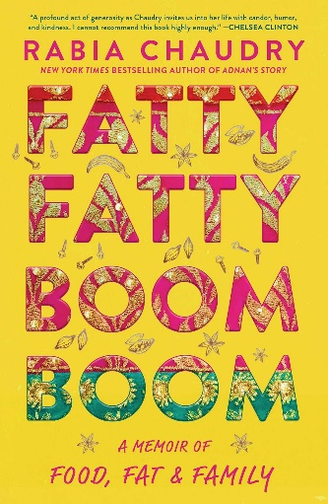

Pakistani-born lawyer and media personality Rabia Chaudry is best known for co-hosting the popular Undisclosed podcast — and for her tenacious advocacy for wrongfully convicted family friend Adnan Syed, whose case was featured on Sarah Koenig's 2014 Serial podcast.

In a quirk of unexpected timing, Chaudry's memoir about a more personal struggle — her lifelong battle with her weight — is out just weeks after Syed's long-sought exoneration and release from prison. Like many memoirs about personal demons, Fatty Fatty Boom Boom delves into the author's childhood to give a candid account of her various mortifications, of the flesh and otherwise.

Chaudry describes how she became addicted to calorie-dense junk foods after her family moved from Pakistan to America, "the land of edible convenience," when she was a baby. After being bottle-fed with half-and-half and teething on frozen sticks of butter, she moved on to cheap white bread and fast foods. The takeout lineup wasn't all bad: It helped her learn to read by the age of 4 — A is for Arby's, B is for Burger King, C is for Coca-Cola, and so on.By the time she visited extended family in her native Lahore at 2, she was seriously chubby. When she returned again at 11 for an aunt's wedding, relatives were alarmed by her heft. In a culture in which overweight and dark-skinned girls were considered less marriageable, she had two strikes against her. She learned that weight standards for men and women were not the same. A paunchy uncle spelled it out for her: "Men can look like anything, as long as they have good jobs. But girls cannot look like middle-aged women before they're even married."The book's title comes from what another overweight relative fondly called her over breakfast in Lahore one morning. Other, less kind comments about her body were seared into Chaudry's memory. When she was separated from Zuba Aunty in a crowd and nearly missed their bus, someone yelled to her panicking aunt, "Don't worry lady, your baby buffalo made it."Chaudry self-soothed with food, which added padding and in turn fed her self-loathing. She made it through law school as a young mother and abused wife on a furtive diet of fast food washed down with supersized Cokes before rushing home to cook for her in-laws. In the early months of her happier second marriage, she and her husband, a fellow foodie, each gained back the weight they had lost for their wedding. They continue to support each other through two children and, as she puts it in her dedication to him, "through literally thick and thin."Chaudry writes that her determination to change the way she looked was amplified by her dismay at what she saw in the coverage surrounding her 2016 book, Adnan's Story, and the HBO documentary about it. "When you're a female public personality and people don't like your ideas, it's often your looks that get targeted, low-hanging fruit for the trolls," she writes.Fatty Fatty Boom Boom is dedicated "to all those who have spent their lives being judged — and judging themselves — for their weight." Many readers will eat it up, finding consolation in Chaudry's story. But even those who, like Chaudry, have felt "trapped on the perpetual hamster wheel of weight loss and gain," may tire of the minutely chronicled binges and weigh-ins.

The fact is, there are far more interesting things about Chaudry — and this book — than her weight. For starters are her evocations of Pakistan's family-centric culture.No spoiler here, Chaudry also describes, as the genre demands, how after a lifetime of seesawing weight despite starvation diets, killer exercise regimes, and even surgery for a gastric sleeve, she finally gained control over her body through a combination of working with a trainer to build muscle, healthier food choices, and a healthier relationship to eating.She is defensive about accusations that her determination to slim down demonizes fatness and undercuts body positivity and self-acceptance. "Don't make me feel terrible now, yet another failure, for not being able to feel great no matter what," she pushes back. "Every person, I'd argue, has the right to pursue what feeling good means to them."In fact, atypical of inspirational weight loss books, Fatty Fatty Boom Boom, is, among other things, a love letter to Chaudry's native cuisine. Her memoir's table of contents reads like a menu, with chapters named for beloved Pakistani dishes. An appendix serves up her favorite recipes for ghee, chai, daal, pakoray, kababs, and chicken pulao, among others. Why? "Because everyone has to eat, yes, even fat people...and so many of the best memories of my family revolve around food."

# 'White Horse' is about supernatural horrors — and everyday horrors

# Erika T. Wurth's White Horse

Erika T. Wurth's *White Horse* belongs to the new wave of horror fiction that delivers the creepiness and darkness readers have always associated with the genre, while also packing plenty of social commentary.

Also — and perhaps more importantly — *White Horse*is a horror novel that subverts one of the elements at the core of the genre from the beginning: Instead of the writer being someone who is afraid of the other, the writer *is* the other.

Kari James is an Urban Native living near Denver. She loves heavy metal, idolizes Dave Mustaine, dresses mostly in black, and loves horror fiction. Kari spends her days working at different bars, taking care of her father, who suffered brain damage in a car accident, hanging out with her cousin Debby, and drinking at a bar called White Horse. However, her relatively simple life is marred by her mother's absence. Kari's mother, Cecilia, abandoned her and supposedly died mysteriously when she was a baby — and her memory has haunted Kari ever since. Kari's father is in no shape to offer clarifying information.

Also, Kari constantly worries about her father, her cousin Debby's marriage to a hard-drinking, manipulative man, and the death of her best friend years before, which she thinks she could have prevented. When Debby hands Kari a traditional bracelet that once belonged to Cecilia, Kari starts seeing ghosts, having horrible nightmares, and having gruesome visions of her mother and a tall, shadowy creature known as the Lofa. The visions refuse to go away and Kari soon becomes convinced her mother is trying to tell her something about what happened to her. Looking for answers and a clearer idea of what happened to her mother, Kari embarks on a journey that brings her closer to her roots — and to her mother's life and mysterious ending.

White Horse is about supernatural horrors and everyday horrors. As Kari learns to cope with the visions of her mother's bloody, screaming ghost and the menacing presence of the monster that haunts her, she is also forced to deal with Debby's controlling husband and the way he keeps getting in their way and wedging himself between them at all times. Also, her worrying about her father is constant and the grief and guilt she feels about her best friend's death are always present. It pops up to the surface of her psyche to attack her regularly, especially after she sees her friend's ghost outside a bowling alley. The mixture of supernatural menace and real life darkness works well, in part because Wurth's pacing is superb and the darkness of the narrative is relentless; it's never bogged down by unnecessary details or empty dialogue.

Wurth does many things well in White Horse. The dialogue is snappy and to the point and the descriptions are short and effective. Also, the story hits the ground running and builds as it moves forward, but it never slows down and there is no time wasted on long setups or introducing every character. Instead, readers get to know everyone involved organically as the narrative moves forward. The result is a 320-page novel that's an easy, fast read and that almost demands to be devoured in a single sitting.

Wurth, an Urban Native of Apache/Chickasaw/Cherokee descent who was raised outside of Denver and still lives in the area, brings Denver and a few nearby towns to the page with authenticity. Her identity is clearly a lens through which the narrative is told, keeping the history of Native Americans in the area, and in the entire United States, present at all times. Also, places like Colfax Avenue and the Tattered Cover bookstore show up a few times, along with many local bars and businesses — not to mention a few appearances of Stephen King's The Shining, which takes place in Colorado in the 1970s. Taken together, these things and places make White Horse a quintessentially Denver novel that does for that area of Colorado what the work of James Ellroy has done for Los Angeles or what Philip Roth's oeuvre did for Newark.

Kari is a unique character that pulls readers in and never lets go. She's strong and independent, but also strangely fragile and flawed. Her love for her father is heartwarming and her grief about her best friend's death is touching, but she's also wrong about Debby's situation, quick to anger, and foulmouthed, all of which contribute to making her more believable. As Kari pushes forward against her family, her instincts and, eventually, even the FBI to find out what happened to her mother, it is impossible not to root for her, and that empathy is precisely what makes this horror story work. Wurth has created a strong Urban Native character, and in the process — and while talking about the folklore of various tribes and the American Indian Movement — has pushed against narratives that perpetuate Native American clichés, which makes this a must-read.

# Women's work is never done: a trio of art books showcasing women

# Covers of art books featuring women.

One of many happy results of the publishing industry's push for greater inclusivity: more art books showcasing not just women's art, but women's capabilities.

Three recent standouts feature female subjects of every shape and hue from all over the world, doing the things that women have historically done — and also the things that men have historically done. With few words, these books speak volumes. All would make great gifts. A look:

### The Only Woman

In The Only Woman, Immy Humes has collected 100 mainly black and white group photographs that feature a lone, trailblazing woman "who claimed space in a man's world."

There are familiar faces among these standouts, including banker Christine Lagarde, Pakistan Prime Minister Benazhir Bhutto, writer and wit Dorothy Parker, and Washington Post publisher Katharine Graham. A young Frida Kahlo looks tiny beside her enormous husband-to-be, Diego Rivera, photographed with a contingent of all-male painters, sculptors and other arts workers at a 1929 May Day march in Mexico City. War correspondent Martha Gellhorn, in a no-nonsense trench coat, engages with soldiers on the Italian front a few months before D-day in 1944. British Prime Minister Margaret Thatcher sits front row center at 10 Downing Street in a shirtwaist dress, flanked by the two dozen men in dark suits who made up her new cabinet in 1979.

Even more fascinating are some of the stories behind lesser known female vanguards — including a shipyard worker, a race car driver, a gold miner, and several scientists, nurses, and medical students. Clarissa Wimbush stands out as the only female member of Virginia's all-Black Old Dominion Dental Association in 1961, as does Gloria Richardson, the only woman at a meeting of Black Civil Rights leaders with Attorney General Robert F. Kennedy in 1963.

The solo woman at the 1946 assembly of the American Society of Sugar Beet Technologists (yes, really) is easy to spot because of her elaborate hat. But other "Onlys" are harder to pinpoint in these crowded, small format reproductions — lending Humes' book a fun Where's "Walda" vibe at times.

### Women Holding Things

Women Holding Things combines so many wonderful elements of Maira Kalman's work: her uncanny ability to balance whimsy and worry, simplicity and depth — and thoughts both mundane and philosophical in spare text and colorful paintings, which often channel Matisse. This volume is an expanded version of a self-published booklet Kalman produced during the pandemic to raise funds to combat hunger.

Unusual for Kalman, the text is typeset rather than handwritten, but the book's jacket copy features her appealing, irregularly capitalized hand lettering. It sets the tone: "You hold in your hands a thing I hold most dear. A Book. If there was ever a time to hold onto SOMEthing, this is it. Hold on, dear friends. Hold on." (Spoiler alert: The charming back jacket reads, "One more Thought. Along with holding on, you could also LET GO. But that is ANOTHER BOOK.")

In paintings bright with jewel-toned pinks, reds, and greens, there are women holding red balloons, tea cups, and garden shears. Several visitors to a museum sculpture garden are holding opinions about modern art, while others are holding court or holding wolves at bay. With Kalman's typical wry wit, stolid Gertrude Stein is depicted at her desk, "holding true to herself writing things very few people liked or even read." A tense Virginia Woolf is shown as "barely holding it together."

Like The Principles of Uncertainty, in which Kalman touted the benefits of "meaningful distraction" in the face of a troubling, often unfathomable world, Women Holding Things ventures into autobiographical material. An atypically dark painting depicts a mother holding the hand of her child as they are being shot by Nazi soldiers in Belarus during the Holocaust — which is what happened to the family Kalman's father left behind when he emigrated to Palestine before the war. A painting of two girls in identical yellow dresses that also appeared in Uncertainty, now carries the rubric, "women holding a grudge," along with the story behind the lifelong animosity between Kalman's mother-in-law and her twin sister.

Of course, Women Holding Things is also filled with many of the things Kalman holds dear and loves to paint — chairs, hats, parks, gardens, ruby red bowls of cherries, vases of red, pink and yellow anemones. In portraits of women holding everything from dog leashes and whisks to malicious opinions, Kalman's latest offers an encouraging paean to fortitude and perseverance.

### Great Women Painters

Great Women]Painters, which complements Phaidon's Great Women Artists and last year's Woman Made: Great Women Designers, showcases more than 300 painters born in 60 countries during the 16th to 21st centuries. This handsome coffee table book is arranged alphabetically, from Pacita Abad and Mary Abbott to Marguerite Zorach and Portia Zvavahera.

You'll find plenty of familiar names like Georgia O'Keeffe, Alice Neel, Gwen John, Hilma af Klint, and "the premiere Old Mistress superstar[s]" Artemisia Gentileschi and Élisabeth Vigée-Lebrun. But there are also lesser known artists like Dotty Attie, Anita Rée, Carmen Herrera, and Giulia Lama, and emerging stars like Dana Schutz, Jenny Saville, and Amy Sherald (who painted Michelle Obama's official portrait) — which makes for a rich mix. Each artist is represented by one key painting and a short biographical note.

The goal, writes Alison M. Gingeras in her introduction, is to "renegotiate the canon" by "casting aside the yardstick of auction prices and the subjective categories of aesthetic beauty, technical mastery and 'wall power.'" She argues that instead, "the calculus of valuation" needs to take into account the works' historical context and intellectual content, and the "singularity and difference" of women artists.

There are delights in every era and genre. Some paintings, like Frida Kahlo's "Self-Portrait with Thorn Necklace and Hummingbird," Yayoi Kusama's "Pumpkin," and Marilyn Minter's extreme closeup of lips in "Big Red" are well-known. But surprises abound, not just from artists whose work I was not familiar with, but from lesser-known paintings by well-known artists. Mary Cassatt, often associated with her soft-focus Impressionist canvases of mothers and children, is represented by "In the Loge," which features a woman gazing intently through opera glasses. Leonora Carrington's "The Old Maids" depicts a sort of Surrealist tea party filled with creatures who might have stepped out of a fairy tale. In "The Only Blonde in the World," British Pop artist Pauline Boty's portrait of Marilyn Monroe in one of her best-known roles is set against an abstract background that suggests the divide between the actress' public image and her private self.

Among contemporary works, I was particularly intrigued by Iranian-born Sanam Khatibi's feminist twist on Renaissance pastorals in "Thirty Days of Hunger," Latvian Ella Kruglyanskaya's muscular joggers in "Exit in Flip Flops," and one of Celia Paul's haunting, earth-toned family portraits, "My Sisters in Mourning."

Grandma Moses' folk art "Summer Party" presents a happier scene, and I was glad to be reminded that the late-blooming artist's real name was Anna Mary Robertson Moses. The names and work of all these painters deserve to be better known.

# 10 books to read to learn about women's plight in Iran

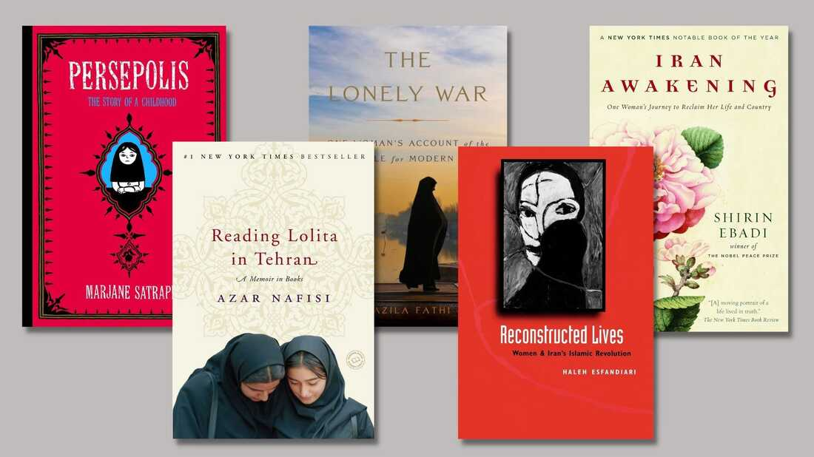

Mass [demonstrations](https://www.npr.org/2022/10/29/1131830324/india-hijab-iran-protests) happening in Iran were sparked by the death of a 22-year-old woman named Mahsa "Jina" Amini, in a Tehran hospital on Sept. 16, two days after her arrest by Islamic Republic authorities for failing to properly cover her hair.

Hijab is mandatory in Iran and is enforced by morality police. Iranian officials claim she suffered a heart attack, but witnesses at the police station and her relatives say Amini was severely beaten while she was in custody.

Videos and posts on social media and independent news reports show the resulting Iranian protests — the largest since 2009 — are being violently and often fatally suppressed by Iranian security forces. Many women and girls at these demonstrations have removed their own headscarves in public and cut or shaved their hair. The images and reports have spurred solidarity protests around the world.

But the uprising in Iran is about much more than mandatory hijab.

We have put together a reading list that can offer insight into Iranian women and what is happening in their country. This list of 10 books was complied with the help of fellow Iranian friends and family, including journalist and author Nazila Fathi; refugee and migration law expert Parastou Hassouri, comedian Maz Jobrani, and Maryam Haghbin, a Montessori field consultant (and also my cousin). Many are memoirs by women who were forced to flee Iran:

***Persepolis (I and II)*** by Marjane Satrapi, a French-Iranian illustrator and children's author. The engaging memoir told in comics as well as its film adaptation are about her childhood in Iran and adolescence in Europe — and describe how the four-decade old revolution that toppled the Shah ended up oppressing the public it purported to liberate, especially women.

**Until We Are Free: My Fight for Human Rights in Iran** by Shirin Ebadi, the 2003 Nobel Peace Prize winner and judge who because of her sex was forced from office in the Islamic Republic — yet remained defiant. This is her second memoir.

**Iran Awakening: One Woman's Journey to Reclaim her Life and Country** by Shirin Ebadi (with journalist Azadeh Moaveni). Her first memoir, chronicling her earlier years and how the Iranian revolution that so many embraced turned into a theocracy.

**The Lonely War: One Woman's Account of the Struggle for Modern Iran,**by Nazila Fathi, a former New York Times reporter who seamlessly weaves her compelling story as a journalist ultimately forced to flee her native Iran with the post-revolution history of her country.

**My Prison, My Home: One Woman's Story of Captivity in Iran** by Haleh Esfandiari, an Iranian-American scholar and former director of the Middle East Program at the Woodrow Wilson Center. The memoir delves into her arrest on false charges and her time at the notorious Evin Prison.

**Reconstructed Lives: Women and Iran's Islamic Revolution**by Haleh Esfandiari, who presents interviews with Iranian professional and working women and their dramatic accounts about what has happened to them following the 1979 revolution.

***Women and Revolution in Iran*** by Guity Nashat, a historian and researcher who edited this collection of essays featuring various perspectives on the participation of women in the 1979 Islamic revolution in Iran and its complexities.

**Between Warrior Brother and Veiled Sister: Islamic Fundamentalism and the Politics of Patriarchy in Iran** by Minoo Moallem, a professor of gender and women's studies at the University of California at Berkeley. She analyzes modern Iran and, while critical of the treatment of women, sets aside stereotypes of Islam and Muslims as fanatical and backward.

**Honeymoon in Tehran: Two Years of Love and Danger in Iran** by Azadeh Moaveni, former journalist who directs the Gender and Conflict Program at the International Crisis Group. This is her second memoir, an engaging account of her personal and professional life in Tehran during the rise of populist President Mahmoud Ahmadinejad.

**Reading Lolita in Tehran**by Azar Nafisi, an English literature professor. This bestselling memoir about a clandestine book club she hosts at her home in Tehran draws readers in, but has been criticized by many in the Iranian diaspora and some non-Iranians for portraying Iranian themes through a narrow, Western lens.

# With 'Foster,' Claire Keegan asks that readers look outward

# Foster by Claire Keegan

Claire Keegan has been compared to the Russian author Anton Chekhov and fellow Irish writer William Trevor. She shares their keen sense of empathy, eye for the telling detail, and deep attunement to the moral issues raised by meanness and suffering for witnesses as well as the afflicted.

Keegan's output is scarce and her stories are as spare as they are heartrending, whittled down to the essential. If she has published anything that isn't perfect, I haven't seen it.

Since its original publication in 2010, Foster has become part of the school curriculum in her native Ireland. It appeared in a slightly abbreviated version in The New Yorker, but this new standalone volume is the first publication of the full text in the U.S. It is a beautiful companion to last [year's Booker-shortlisted](https://www.npr.org/2021/12/22/1065780684/claire-keegan-book-small-things-like-these-magdalene-laundries) Small Things Like These, her Christmas story and morality tale that makes Dickens' Christmas Carol and Hans Christian Andersen's The Little Match Girl seem like glitter-dusted fairy tales. Together, this pair of Keegan's novellas pack a one-two punch.

The nameless narrator of Foster is a little girl whose parents, impoverished Catholic farmers already overwhelmed by too many children and the father's bad habits, farm her out to distant relatives she's never met when her mother's belly is "hard with the next baby." When her father drives her after Mass one summer Sunday "deep into Wexford towards the coast where my mother's people came from," she has no idea what to expect — whether she'll be worked hard or treated kindly, and for how long.

We come to recognize the deprivations of the girl's former life indirectly, through the things she notices, which are so different from what she's used to. "Tall shiny panes," clean kitchen tiles, daisies on the table, the smell of disinfectant and bleach and the rhubarb tart in the oven all strike her as remarkable. When Mrs. Kinsella, even taller than her mother, "looks at my clothes, I see my thin, cotton dress, my dusty sandals through her eyes." The girl quickly recognizes that "this is a different type of house. Here there is room, and time to think."

Before her father hurries off without so much as a hug, he warns the Kinsellas that the girl eats a lot, "but ye can work her." The girl notices Mr. Kinsella's reaction, a subtle reprimand to her father: "Kinsella looks up. 'There'll be no need for any of that,' he says. 'The child will have no more to do than help Edna around the house.'" Later, the girl describes her daily routine: "Myself and Mrs. Kinsella make a list out loud of jobs that need to be done, and just do them" — clean the house, weed the garden, dig potatoes, pull rhubarb, make tarts.

Mrs. Kinsella bathes her, cleans her filthy fingernails, deals with her urine-soaked bedding — all without reproach. In the night, she checks on the girl, who hears the woman whisper, "God help you child. If you were mine, I'd never leave you in a house with strangers." When the woman starts to see the effects of their care, she says, "All you need is minding."

Gradually, from a series of pointed comments by neighbors, the girl learns about the boy whose clothes she was given to wear before the Kinsellas "tog her out" in her own new wardrobe, and the hole in the Kinsellas' life that she is filling. After a particularly malicious woman tells the girl about the Kinsellas' lost son and fishes for gossip about her bereaved caretakers, Mr. Kinsella walks her down to the sea to comfort her. He says, "You don't ever have to say anything...Many's the man lost much just because he missed a perfect opportunity to say nothing." It's a lesson she takes to heart when her mother later grills her about her stay with the Kinsellas.

One of the things Keegan gets so right here is how painful unaccustomed love and tenderness can be because they accentuate what's been lacking. Walking to the beach, Mr. Kinsella thoughtfully adjusts his strides to the child's and takes her hand. She notes, "my father has never once held my hand, and some part of me wants Kinsella to let me go so I won't have to feel this." Then she adds, "It's a hard feeling but as we walk along I begin to settle and let the difference between my life at home and the one I have here be."

At first blush, Foster brings to mind Kaye Gibbons' searing 1987 debut novel, Ellen Foster, narrated by a plucky disadvantaged 11-year-old girl who is relieved, after much hardship, to land in a home where she is loved and wanted, forever free of her abusive father.

But the dilemma in which Keegan's narrator, a victim of neglect rather than abuse, finds herself is more similar to that of the boy in Graham Swift's Here We Are, whose loyalties are torn between the harsh life he led with his struggling, bitter mother and the privileged existence he shared with the kind, loving foster parents to whom he was sent from Blitz-battered London during World War II. Keegan, like Swift, captures how particularly hard the ensuing guilt can be on children.

More than most books four times its size, Foster does several of the things we ask of great literature: It expands our world, diverting our attention outward, and it opens up our hearts and minds. This is a small book with a miraculously outsized impact.

# A reporter's memoir of her jail time gets banned in Florida prisons



One journalist's memoir of rehabilitation is being banned in Florida state prisons.

*Eric Francis/Getty Images*

When an author's book gets banned or confiscated, one might imagine that the writer might be frustrated, or even angry.

But when Keri Blakinger received word that the Florida state prison system placed her book, *Corrections in Ink*, on a temporary ban, [she tweeted](https://twitter.com/keribla/status/1585334155780366336), "Honestly, I AM SO PROUD."

Blakinger, who is a journalist covering prisons for The Marshall Project, was really respondingtongue-in-cheek — an ironic response to a truly head-scratching situation.

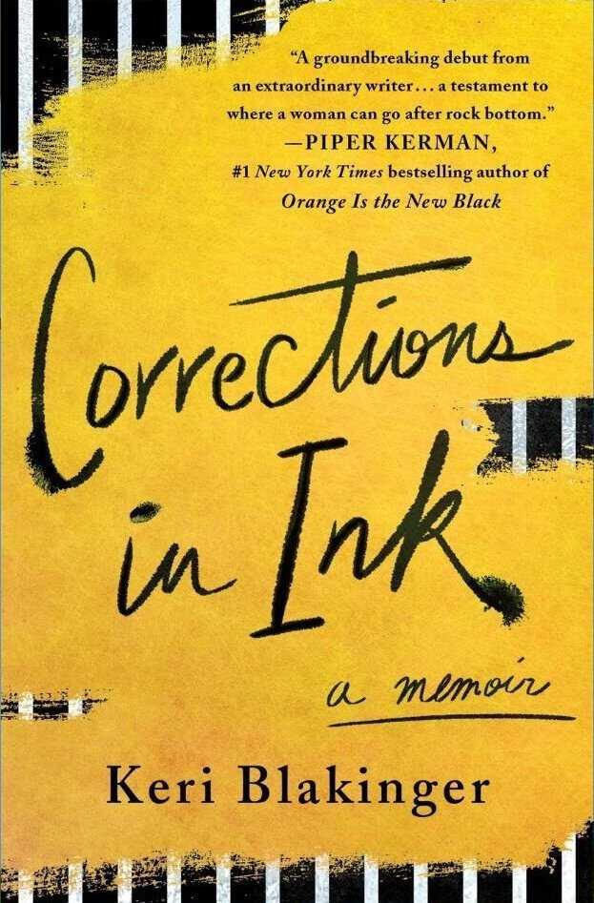

*St. Martin's Press*

"It's kind of hilarious that the prison system — now that I am rehabilitated and doing good things in the world — says that my writing is dangerously inflammatory," she told NPR. "I also think it's absurd that one of the reasons for the ban was that the book presents 'a threat to the security, order or rehabilitative objectives of the correctional system.' The book is literally a story about rehabilitation."

Blakinger was notified about the ban by The Prison Book Program, a nonprofit group that had attempted to send a copy of her memoirto an inmate. The book was instead impounded, meaning that until the Florida Department of Corrections' Literature Review Committee approves of the book, it's banned from every state-run carceral facility.

The department told NPR that Corrections in Ink is currently under review by the committee, which will determine if "it contains subject matter that is inadmissible per Florida Administrative Code." Under the policy, the book's publisher is afforded the opportunity to appeal the decision.

"The next meeting will be held in coming weeks, so it is too soon to provide a determination for the publication," the spokesman said.

### State-level prisons' banned book lists raise questions

While Keri Blakinger's book is banned in Florida, some states don't explicitly ban extremist texts like Adolf Hitler's Mein Kampf.

*Matthias Schrader/AP*

Coincidentally, as part of Blakinger's work with The Marshall Project, she's recently submitted records requests for state-level prisons' banned book lists.

She's found that some state prisons ban books on a case-by-case basis. Others have a set list of forbidden books.

"How big those lists are and what sorts of materials they include varies quite a bit," she said.

Some states have very small lists, with only a few hundred titles. Other states, like Florida, Texas, Michigan and California, have lists with thousands of titles on them. And the ones chosen often don't make a ton of sense, Blakinger said.

"Texas has banned The Color Purple. Michigan bans Dungeons and Dragons books," she said, referring to the famous tabletopfantasy roleplaying game.

Michigan has [also banned dictionaries in Spanish and Swahili](https://www.npr.org/2022/06/02/1102164439/michigan-prisons-ban-spanish-and-swahili-dictionaries-to-prevent-inmate-disrupti#:~:text=Press-,Michigan%20prisons%20have%20banned%20Spanish%20and%20Swahili%20dictionaries.,prevent%20prisoners%20from%20being%20disruptive.https://www.npr.org/2022/06/02/1102164439/michigan-prisons-ban-spanish-and-swahili-dictionaries-to-prevent-inmate-disrupti#:~:text=Press-,Michigan%20prisons%20have%20banned%20Spanish%20and%20Swahili%20dictionaries.,prevent%20prisoners%20from%20being%20disruptive.)under claims that the books' contents are a threat to the state's penitentiaries. Prison officials said they feared inmates would learn an "obscure language" and organize against staff.

There are some books that are banned for security reasons, and for good reason, Blakinger notes.

"Maybe you don't want books that teach bomb making. Admittedly, if somebody's getting the materials for a bomb, you probably have a much bigger security issue than the book," she said.

Oddly enough, Blakinger has found books championing extremism and white supremacy like The Turner Diaries and Adolf Hitler's Mein Kampf are rarely prohibited in prison.

Blakinger provided NPR with a list of other banned books within the Florida prison system that she received through a records request. It appears that, for now, her memoiris prohibited alongside porn and books on the Japanese language, yoga and fantasy football.

"[Florida has] one of the largest banned books lists of all the states with lists that I've reviewed. They're the 1st I'm aware of to flag mine," she said on Twitter. "And while I am not happy it is impounded, impoundment for being 'dangerously inflammatory' is pretty dope. But the idea it poses a threat to security or to the 'rehabilitative' goals of prison is LAUGHABLE... my book is more rehabilitative than Florida prisons have ever been."

# Bono discusses his new memoir, 'Surrender,' and the faith at U2's core

It was 1976. An Irish kid named Paul Hewson was trying to figure a lot of things out; his mom had died a couple years earlier, when he was just 14. [Bono](https://www.npr.org/artists/15289501/bono), as he was known, spent a lot of time at home, in Dublin, arguing with his dad and his older brother. But two goals kept him focused — to win over the heart of a girl named Alison Stewart and to become a rock star.

And in the same week, he asked Alison out — (she said yes) — and he ended up in Larry Mullen JR's kitchen for an audition. Two other guys were there — Adam Clayton and David Evans, also known as The Edge. The four of them would go on to become one of the biggest bands of their time: U2. And he is still married to Alison Stewart 40 years later.

Bono writes about these foundational relationships in his new memoir, called [Surrender: 40 Songs, One Story](https://www.penguinrandomhouse.com/books/566576/surrender-by-bono/), releasing Tuesday Nov. 1. In it, he also delves into another core relationship: his spirituality. Though never a Mass-on-Sundays kind of Catholic, from a young age he was fascinated with mysticism and ritual – and Jesus.

The following has been edited and condensed. To hear the broadcast version of this conversation use the audio player at the top of this page, or watch a longer cut in the video [here](https://youtu.be/JhkamXR0esU). Additionally, an extended version of this interview will be available on Sunday, Oct. 30, via [Up First](https://www.npr.org/podcasts/510318/up-first), NPR's daily news podcast.

**Rachel Martin, *Morning Edition*: You write in the book, "If I was in a café right now, and someone said 'Stand up if you're ready to give your life to Jesus,' I'd be the first to my feet." Did your band share your focus, your preoccupation, with faith?**

**Bono**: They still do. At first, Adam [Clayton] was just like "Aw, *man ..*." You know, he had just one thing in life, he's a bass player — just wants to be in the bad-ass rock and roll band ... But he stood by me, you know, and stood by us in our devotion.

Could you imagine Ireland in the '70s, it's a civil war — all but a civil war. The country's dividing along sectarian lines. I was very suspicious, and still am a little suspicious of ... religious people, I mean, religion is often a club that people use to beat someone else over the head with. I learnt that at a very early age in Ireland.

**You write that a lot of U2's music is grounded in the feeling, the emotion, even the structure, of a hymn.**

Edge's family were Welsh — if you've never heard crowds singing at a Welsh-Irish rugby match, the stadium *filled* with song. They sing these huge hymns, and the Welsh sing as a crowd really, *really* well. [*Singing*] "Bread of heaven, bread of heaven ... we'll support you evermore..."

And it's in him, it's in Edge, those fifths. And that's the feeling we've been looking for in our music — yes we want punk rock, we want it to be brutal, we want it to be tough-minded, we wanted to have big tunes. But the ecstatic music is part of who we are.

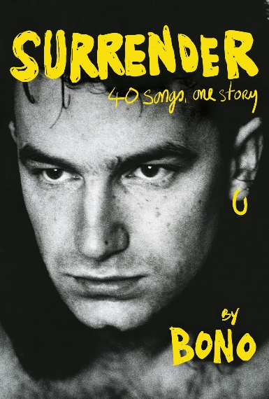

[*Penguin Random House*](https://www.penguinrandomhouse.com/books/566576/surrender-by-bono/)

**With "Still Haven't Found What I'm Looking For," you say explicitly that in that song, there's some kind of root of that?**

Yeah. It's a gospel song — it's a psalm, if you wanted to ...

**What's a "sam"?**

Sorry, did I not pronounce that right? [*Exaggerated*] "*Sam,*" is that how you say it, Rachel? You're so posh!

**Your dad said, near the end of his life, that the most interesting thing about you was your spirituality, was your religion.**

My faith, yeah. He was brilliant. He had faith and he lost it, you know, and people do — just when you need it. When he was dying, I write in the book, I'd gone in to see him and I was reading him bits of scripture and he was kinda giving me the hairy eyeball. [*Laughs*] A little bit of "Knock it off, will ye?" And I was so sad for him that he didn't have that, because he had always said to me things like, "You know, this stuff, this God stuff, I don't experience that — but you shouldn't give that up, 'cuz it's the most interesting thing about you," he says. Sort of a classic ...

**I mean, was that sort of a slight to you? You're this musician ...**

Now you're picking it up — his compliments would arrive either with a tickle or a boxing glove. [*Laughs*] I remember when we were recording U2's first album, he's like, "What're you doing?" And I said I've just been recording the album, and he's like, "You've been doing that for *weeks*." And I said yeah, it's three weeks — this is the last week. And he says "how long is an album?" About 40-odd minutes ... "Oh God, will you get it right? *Get it right*."

**[*Aside*] After 40 years of selling out arenas as a musician, trying to eradicate hunger and AIDS as an activist, and also being a father and a husband, Bono is ready to admit he hasn't gotten it all right**--**the Dublin kid who's always been the big voice at the center is ready to hear what others have to say.**

"Just shut up and listen" is kind of where I'm at, at the moment. I just need to be more silent, and to surrender to my band as being at the core of what I'm trying to do with my life, surrender to my wife — and when I say "surrender," I do *not*mean making peace with the world. I'm not ready to make peace with the world. I'm trying to make peace with myself, I'm trying to make peace with my maker, but I am *not* trying to make peace with the world. The world is a deeply unfair place, and I'm ready to rumble. I'm keeping my fists up for that one.

# 3 books in translation that ask a lot — and allow the reader to ask a lot in return

# Covers of Concerning My Daughter, Hugs and Cuddles and Freeway: La Movie.

Subtlety gets a lot of praise in the realm of literature.

Many readers, critics, and editors see delicacy, especially on the thematic front, as a sign of quality and challenge, which it frequently is. But gentle, subtle novels are far more common than ones that take the opposite tactic, announcing their difficulty or their defiance from the very first page — a brave strategy, and one that creates a uniquely exciting relationship between author and audience. When a book declares itself a challenge right away, its readers get to make the conscious choice to rise to the occasion. Doing so generates a sense of investment; it also heightens our expectations. If an author asks a lot of us, we get to ask a lot of that author, too.

None of the novels below pretend for a moment to be easy. Kim Hye-jin's Concerning My Daughter, translated from the Korean by Jamie Chang, demands a taxing quantity of empathy from its readers and protagonist alike; the Brazilian literary master João Gilberto Noll's erotic odyssey Hugs and Cuddles, translated from by Edgar Garbelotto, shatters any prudery or sexual squeamishness readers may bring to the book; and the Cuban writer Jorge Enrique Lage's cyberpunk Freeway: La Movie, translated by Lourdes Molina, is so disorienting that it stretches our ideas of narrative. All three books are tough — and all three are completely consuming. They demand our full attention, and then they earn it.

### **Concerning My Daughter**

Concerning My Daughter is a tiny, blunt book. Its twin subjects are homophobia and class disadvantage, which Kim Hye-jin links on nearly every page. Kim's nameless narrator, a middle-aged widow barely supporting herself by temping in awful conditions as a nursing-home aide, cannot bear that her adult daughter, Green, is gay; indeed, just hearing her daughter say the word lesbian makes her feel like a "cornered animal." Often, the narrator's prejudice — which, Kim is quite clear, is informed both by a desire for her daughter not to be discriminated against and by real revulsion at the idea of lesbian sex — is nearly unbearable to read. Yet Kim is equally clear that Green's mother, repellent as she can be, deserves empathy. Her financial straits have driven her into a constricting survival mode: she avoids intimacy and friendship, is terrified to stand up for herself or her patients at work, and allows Green and her girlfriend Lane to move in with her rather than sell a house she can't afford, but sees as the "only thing over which I can claim control and exercise ownership."

Concerning My Daughter is often didactic, privileging message over plot. Kim lets both Green and Lane deliver monologues about their right to acceptance; she also lets the narrator monologue, if only to the reader, about the precarity of her life. None of these passages are lectures, though: Kim gives them such emotional heft that they can only be pleas. Jamie Chang's translation, which is plain yet highly precise, amplifies this effect. She leaves no ambiguity in the text, which means the reader cannot hide from the intensity of the narrator's feelings. Ultimately, Concerning My Daughter turns into a confrontation — not just between Green and her mother, but also between Green's mother and the reader. Understanding, in this book, has to come from all sides.

### **Hugs and Cuddles**

If you were to casually leaf through João Gilberto Noll's Hugs and Cuddles, not knowing much about Noll's work, you'd assume it was erotica. (And it could be!) Noll, a [highly influential](https://lithub.com/investigating-the-brilliance-of-the-late-joao-gilberto-noll/) Brazilian postmodernist who died in 2017, wrote frequently about queerness, defiance, and the freedom that can come from life outside mainstream society's confines. It's a theme that's quite literal in Hugs and Cuddles, which gets moving after the middle-aged narrator's great unrequited love, known as "my engineer friend," invites him to a gay orgy on a decommissioned Nazi submarine. Underwater, the narrator is shy, but after disembarking, he enters his own personal "orgiastic age," which includes bathroom-stall sex, sex with a goat, and some surprising sex with his wife. Still, he yearns for a "love affair between two mature men." When this affair finally manifests, the narrator does something that, by Noll's standards, is shocking: He moves to the jungle with the engineer, now his partner, and tries to transform himself psychologically into "the wife [the engineer] had always dreamed of." (Although, granted, he remains a "horny stud" by night.)

Hugs and Cuddles laughs at gender, but takes sex seriously. It is both prurient and philosophical, gleefully dirty and wrenchingly serious. (Except its plot, which is consciously absurd.) Edgar Garbelotto, Noll's translator, does the novel a bit of a disservice by opting not to adapt its prose to the rhythms of the English language, a decision that sometimes stalls its momentum, but Noll's portrait of a man ruled by desire is too interesting to look away from. Hugs and Cuddles intertwines its narrator's longings for sex, submission, novelty, and comfort so seamlessly that, after reading it, you may well wonder if those desires are separable at all.

### **Freeway: La Movie**

In some ways, Jorge Enrique Lage's satirical Freeway: La Movie is perfectly recognizable. It's a picaresque buddy comedy, one of the oldest literary forms: its narrator (who, like Noll and Kim's narrators, is nameless) and his sidekick, El Autista, roam a dystopian Cuba, just like Don Quixote and Sancho Panza roamed 16th-century Spain. But while Miguel de Cervantes grounds readers in Don Quixote's setting, Lage disorients us totally. Starting Freeway: La Movie is confusing in the way the first scenes of action films often are. Events come quickly, with context lagging so behind that readers simply cannot interpret what's happening. Each chapter is a separate, surreal adventure, linked only by narrator and setting: a construction site that turns into a gigantic highway linking Cuba to the United States.

Lage delights in mockery, and Freeway: La Movie is best when he's funniest.

Sometimes his humor is absurdist, as in a chapter in which the protagonist encounters a genie who not only lives in a Coke bottle, but was once Coca-Cola's brilliant, misunderstood chief scientist. (His name, which translator Lourdes Molina smartly leaves in Spanish, is El Genio, which means both genius and genie.) But more often, Lage's jokes are political and pitch-black. His willingness to laugh at serious matters — genocide against indigenous tribes; the prison at Guantánamo Bay; highway builders' tendency to destroy poor neighborhoods — gives Freeway: La Movie an angry energy that will carry willing readers past their disorientation. Of course, Lage also mocks his readers, if only by defying our idea that narratives should make sense. Freeway: La Movie has no real storyline, just a nameless, displaced narrator who's just trying to act as "the only witness to whatever is happening." At some point, aren't we all?

Lily Meyer is a writer, translator, and critic. Her first novel, Short War, is forthcoming from A Strange Object in 2024.

# Cormac McCarthy's new books seem to try to encapsulate the human experience

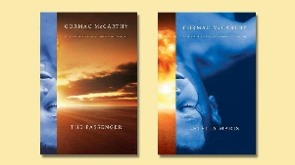

In terms of scope, works of literature exist on a spectrum that goes from small narratives packed into a microcosm that want to explore a single element of human nature all the way to stories that seem obsessed with somehow encapsulating the totality of the human experience and decoding the meaning of life.

Cormac McCarthy's The Passenger and Stella Maris --[the author's first two books in more than a decade](https://www.npr.org/2022/10/22/1130439227/cormac-mccarthy-publishes-two-new-novels-the-passenger-and-stella-maris) — belong to the latter group, both as standalone novels and when taken together as deeply intertwined works of fiction that take place in the same universe and with the same characters.

The Passenger, set mostly in Louisiana in the early 1980s, tells the story of siblings Bobby and Alicia Western (see what the author of Blood Meridian, All the Pretty Horses, The Crossing, and Cities of the Plain did there?). Bobby, who used to be a Formula 2 racecar driver, works as a salvage diver. He's a moody, hard-drinking man who's haunted by the loss of his beloved sister, who committed suicide a decade earlier, and by the ghost of his father, a renowned physicist who helped J. Robert Oppenheimer develop the atom bomb. Bobby works a dive at an offshore plane crash, but it's not a regular job.

The crash never makes the news, important parts of the plane are missing, and one of the passengers isn't inside the plane with the rest of the bodies. After the dive, strange men start following Bobby around and ask him questions. Also, someone repeatedly breaks into his home, forcing him to move and consider abandoning Louisiana altogether. While dealing with the increasing weirdness of the mysterious crash, the strange men shadowing him, and his growing paranoia, Bobby rereads the letters Alicia left behind. Also, readers get vignettes of Alicia dealing with the "cohorts," a group of imagined beings that harassed her.

*The Passenger* is part familial trauma story — including incest — and part slow-burning thriller. However, it's also much more than that. McCarthy writes about everything here, from buried gold and incredibly detailed dives to mathematics and the aftermath of the bombing of Hiroshima and Nagasaki:

"Those who survived would often remember this horrors with a certain aesthetic to them. In that mycoidal phantom blooming in the dawn like an evil lotus and in the melting of solids not heretofore known to do so stood a truth that would silence poetry a thousand years. Like an immense bladder, they would say. Like some sea thing. Wobbling slightly on the near horizon. Then the unspeakable noise. They saw birds in the dawn sky ignite and explode soundlessly and fall in long arcs earthward like burning party favors."

Elegant writing like this is present once in a while, and it's balanced by straightforward prose about everything and nothing: people driving, talking, drinking coffee or beer, meditations on death, observations about nature, staring out the window, or feeding the cat. The back and forth — this is a novel about nothing important/this is a novel about everything that matters — is often surprising, perhaps a bit disjointed and jarring, but it's also unequivocally McCarthy-ish, and it works. The novelist is concerned with the big questions now more than even, and that obsession is present in almost every page.

And then there's Stella Maris.

Consisting purely of dialogue — devoid of the punctuation and dialogue tags commonly used for it, as McCarthy has always done — Stella Maris records Alicia's long, bizarre conversations with a male psychiatrist at the titular mental institution in 1972. While there, Alicia is diagnosed as a paranoid schizophrenic, but she is brilliant — perhaps a genius — and the conversations go from discussing the Thalidomide Kid, an imagined balding dwarf with flippers for hands who constantly visited Alicia, to the difference between reality and human consciousness. Stranger and smarter than The Passenger, Stella Maris is also somehow darker and packed with lines like "The world has created no living thing that it does not intend to destroy" and "I think your experience of the world is largely a shoring up against the unpleasant truth that the world doesnt know you're here."

The Passenger flirts with not being a traditional novel and succeeds. Stella Maris doesn't care about not being a novel, and it shines because of it. The former is dark and mysterious like a night out on the bayou. The latter — a spiritual sister presented as a coda to be published a month later — is wild, profoundly sinister, and more a philosophical exploration and celebration of math-mysticism and the possibilities — and perhaps unknowability? — of quantum mechanics than a novel. Taken together, these two novels are a floating signifier that refuses to be pinned down. They are also great additions to McCarthy's already outstanding oeuvre and proof that the mind of one of our greatest living writers is as sharp as it has ever been.

Gabino Iglesias is an author, book reviewer and professor living in Austin, Texas. Find him on Twitter at [@Gabino_Iglesias](https://twitter.com/Gabino_Iglesias).

# After 16 years, author Cormac McCarthy gifts two new novels to readers

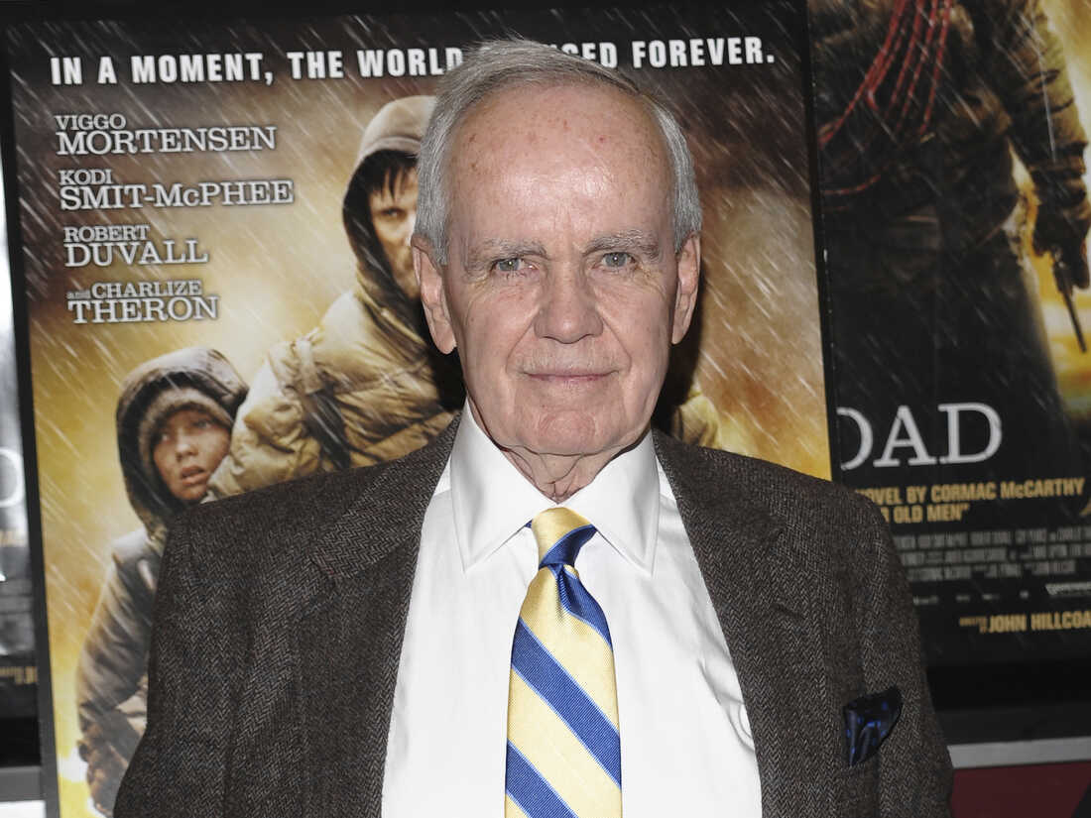

Devoted Cormac McCarthy fans who have been waiting 16 years for new work from the renowned American writer are in for a surprise.

The reclusive author's two new interconnected novels — being released on Oct. 25 and Dec. 6, respectively — are hard to categorize.

The first book*, The Passenger*, opens with a mysterious plane crash at sea that's searched by a neurotic salvage diver who's obsessed with his sister. The entire second book, *Stella Maris*, consists of erudite conversations between that sister, who happens to be a mathematical genius, and a therapist in the psychiatric hospital where she's committed herself.

By all accounts, McCarthy has been working on them for at least four decades.

"Eight years ago, it was so cloak-and-dagger that we were working on these books because McCarthy fans are rabid and any whiff of there being new books is going to be huge news," says Jenny Jackson, executive editor at Knopf, who began working with him in secret in 2014. "We'd walk down the hall and hand off manuscripts in person. And I wasn't telling anyone what we were working on."

For the interview, Jackson comes to the Napoleon House, a venerable watering hole in the French Quarter of New Orleans — where McCarthy lived as a young, penurious writer. The protagonist in *The* *Passenger* isa troubled commercial diver named Bobby Western who frequents the Napoleon House for rambling discourses with eccentric buddies.

"At the beginning," Jackson says, "there's this big cast of boisterous characters and they're all working as divers and having drinks together and going out to restaurants. And then at the end they're each kind of on their own singular journey."

Neither of these two new books contains the savagery and bloodletting McCarthy readers have come to expect. There's less action overall and more dialogue. Readers may wonder if McCarthy has mellowed now that he's 89 years old.

The breathless blurb on the back cover of *The Passenger*reads*:* "A sunken jet. Nine passengers. A missing body...A salvage diver pursued for a conspiracy beyond his understanding." But this is not a fast-paced crime thriller like *No Country For Old Men*, which became an Oscar-winning screenplay for the Coen Brothers.

*The Passenger* starts out as a who-dun-it but then veers into Bobby's metaphysical musings.

"When you're Cormac McCarthy and you've written*The Road*, what on earth can you do next except tackle God and human consciousness?" Jackson asks.

The Road is McCarthy's best-selling last novel, released in 2006, about a father and son's harrowing journey among latter-day cannibals in a post-apocalyptic landscape. It won a Pulitzer.

McCarthy described the genesis of The Road in his only broadcast interview, granted to Oprah Winfrey in 2007. He says he happened to be in El Paso with his young son.

"I just had this image of these fires up on the hill and everything being laid waste and I thought a lot about my little boy. And so I wrote these pages and that was the end of it. And then about four years later I was in Ireland and I woke up one morning and realized it wasn't two pages, it was a book."

The new paired books are more dense than dark. Notably, they reflect McCarthy's love, and thorough understanding, of theoretical physics and mathematics. He has said, in his few interviews, that he seeks out the company of scientists at the Santa Fe Institute near his home in New Mexico.

Determined McCarthy fanatics have found advanced copies of the books, and they have provoked strong reactions. Some McCarthy aficionados were interviewed in September at a Cormac McCarthy conference in Savannah, Georgia.

"The novels explore all these aspects of human mental behavior. I think they're just marvelous," says Diane Luce, former president of the Cormac McCarthy Society.

And Bryan Giemza, literature professor at Texas Tech University, says: "In some ways, they're flawed. They are likely to be inscrutable to a lot of people. Let's just say they're not my favorite novels."

A third early read, Lydia Cooper, English professor at Creighton University, says: "They are brain teasers, but they're also really compelling. The characters are really rich and fascinating. I think people are going to love them or hate them."

One of the organizers of the conference in Georgia was Stacey Peebles, an English professor who teaches a McCarthy course at Centre College, and is editor of the Cormac McCarthy Journal.

"I've had students coming by my office. They say, 'Are you going to teach the new ones? I'm so excited.' "

Peebles has also read both new books.

"We've been waiting for these a long time," she says. "There's always the possibility that you're going to read something new and be disappointed. But I read 'em once. I read 'em again. And I'll probably keep reading 'em. I mean, all of McCarthy's works have sentences that'll just stop you cold, but these have a lot of those."

Here's one of those sentences, from The Passenger (you can read a longer, exclusive-to-NPR excerpt from Stella Maris [here](https://www.npr.org/templates/story/story.php?storyId=1129879339&live=1)):

"God's own mudlark trudging cloaked and muttering the barren selvage of some nameless desolation where the cold sidereal sea breaks and seethes and the storms howl from out of that black and heaving alcahest."

McCarthy — who still composes on a manual typewriter — is considered one of the greatest and most influential writers in the English language.

"I began to notice fairly early on that a lot of these students were writing like Cormac McCarthy," says Texas novelist and historian Stephen Harrigan, who taught a fiction writing course at the Michener Center for Writers at the University of Texas at Austin. He recalls with a chuckle, "They were writing with strange locutions like, 'He rode isolate into the darkling plain.' That kind of language. And this Old Testament archaic usage creates a kind of spell, particularly for young writers."

The McCarthy spell is about to be cast again, and not just for readers but for researchers.

Cormac McCarthy's literary papers are archived in a locked cabinet in the Witliff Collections at Texas State University in San Marcos.

"It's about a hundred boxes of Cormac material that we have here," says Steve Davis, literary curator at the Witliff, as he rolls open the cabinet. "His collection begins with his first book, Outer Dark," and it ends with early drafts of The Passenger.

The last box has been restricted for 15 years, since the Witliff acquired McCarthy's coveted papers, and McCarthy scholars have already been lining up to delve into it. The final box will be opened the same day The Passenger goes on sale — but Davis offered a sneak preview.

"This is the box for the new novel, The Passenger," he says, "and we're gonna pull out this first big folder which says, 'The Passenger, old first draft. Typescript and photocopied pages, heavily corrected in pencil.'"

Perhaps the contents of this box will reveal how Cormac McCarthy's challenging new novels evolved, and why he wrote them.

# Two new books challenge the sense of inevitable permanence of the Chinese party state

# Two books offer perspective on the future of China.

This week, China is treating the world to elaborate political theater mired in secrecy: the 20th Communist Party Congress.

It's a gathering of more than 2,000 top party officials to choose the next iteration of leaders, including the next head of the Communist party. Despite occasional pretentions at democratic consensus, this party congress' objective is being carefully managed to signal the opposite: that the party's leader now, Xi Jinping, has absolute control over all levers of power as he continues into his third term in office.  
  
Watching from afar, it is easy to feel that the party — under the helm of one man — is very much in the driver's seat. Dissent within China is at a minimum, in large thanks to formidable set of digital surveillance and informational controls. Much of the population's every movement remains controlled through zero-Covid measures. An ongoing purge of civil society has obliterated a once-nascent network of media outlets, NGOs, law firms. Despite some internal party tensions, Xi still looks set to appoint his loyalists into power and thus stay locked on a political agenda of national rejuvenation Xi claims has guided the party for the last century.  
  
Two new books challenge this sense of inevitable permanence of the Chinese party state. [China After Mao: The Rise of a Superpower](https://www.bloomsbury.com/us/china-after-mao-9781639730513/), written by Dutch historian Frank Dikötter, charts how the party's control over info and financial and political institutions has endured even in the face of economic waste, ideological vacillation, environmental pollution, and appetite for brutal oppression.

Put another way, the party's greatest success is that it managed to stay in power not because it is all-powerful and all-knowing. Rather, its resilience is rooted in an extraordinary adaptability to handle a long, laundry list of problems — many self-imposed — that would have toppled a less-flexible regime. In just the last four decades, the Communist Party has had only one truly neat transition of power; faced down a bout of near ruinous inflation; fatally crushed pro-democracy protests; and overseen a messy, stop-start combination of capitalist reform and socialist retrenchment.  
  
Nor has the party's current top-down control of all matters political and socioeconomic always been the norm. This is one of the central arguments presented by [Julian Gewirtz](http://www.juliangewirtz.com/), an American historian, [poet](https://www.amazon.com/Your-Face-Flag-Julian-Gewirtz/dp/1556596464), and China advisor on the National Security Council for the Biden administration, in his second nonfiction book [Never Turn Back: China and the Forbidden History of the 1980s.](https://www.amazon.com/Never-Turn-Back-Forbidden-History/dp/0674241843/ref=sr_1_1?qid=1648603991&refinements=p_27%3AJulian%20Gewirtz&s=books&sr=1-1&text=Julian%20Gewirtz)

The slim volume covers the 1970s to early 1990s, a spread of time during which ideas about economic and political reform gestated. Those half-formed ideas towards liberalization that were abruptly thrown out as the party closed flanks following the Tiananmen Massacre in 1989. Where Dikötter's book is a roadmap of how we got here, Gewirtz looks at the road not taken — and a tantalizing glimpse, perhaps, at the political possibilities that remain still.

Gewirtz focuses much on the fascinating character of Zhao Ziyang, general secretary of the party during part of the tumultuous 1980s. Zhao and sympathetic officials argued successfully for China to accelerate international trade, to import — or outright steal — foreign ideas and technology, and to disassociate the party with the blemished legacy of Chairman Mao Zedong.

But the 1980s were not all smooth sailing towards greater market liberalization and political opening, as official Chinese history now casts it. The decade brought numerous setbacks for the reformist camp, including a half-hearted and disastrous experiment with doing away with price controls that led to runaway inflation and ruinous state subsidies. Gewirtz brings to life the ferocious political maneuvering between reformist and Marxist ideologues battling it out over whose vision for what China should become would materialize.

Much of this back-and-forth history was intentionally obliterated as the party, under Deng Xiaoping's directive, wrested back total control over Chinese society in the aftermath of a violent takedown of student and worker protests in Beijing's Tiananmen Square in the summer of 1989. The possibilities that party leaders framed a future China — one that inevitably would be more democratic, more market-driven, less insular — suddenly were winnowed back down to singular party rule.

Intriguingly, Gewirtz utilizes cast-off propaganda directives and internal meeting notes gathered from ragtag collections of loose papers he obtained from online auction sites and Beijing flea markets. These documents allow him to piece together this period of historical re-writing and censorship that would glorify Deng Xiaoping while relegating Zhao Ziyang to the margins. In a sign of how far China has closed itself to independent inquiry, Gewirtz notes that even these archives and auctions have recently been purged of potentially politically sensitive material.  
  
Dikötter, whose three excellent previous books on the tragedies of Communist politics dubbed [the People's Trilogy](https://www.amazon.com/Collection-Dik%C3%B6tter-Liberation-Cultural-Revolution/dp/9123934212), is known for his grassroots telling of sweeping political changes in Chinese history. His newest book is more superficial in its source material, relying heavily on journalistic accounts over the years rather than archival research and oral histories. However, it remains a useful summary fusing together a wildly diverse set of decades of China under Communist rule, emphasizing just how the party has mutated in form and function.  
  
This extraordinary adaptability to meet the perceived challenges of the day is the most novel argument presented in both books. Once resolutely socialist, the party has overseen a surge in the issuing local debt, using the stock market to fund hugely bloated state firms, and created one of the largest property markets in the world — each solving a critical short-term problem while also engendering larger issues down the road.

The party now faces a new raft of challenges, including hostile relations with the United States which has sanctioned some of China's once most-promising technology giants. Will the party survive another round? China's economy remains self-hobbled by unwavering Covid controls, its technology firms bound by dramatic American export restrictions, its officials sanctioned over the country's possible crimes against humanity in the Xinjiang region, and its diplomatic clout has been marred by a nasty dose of nationalism and a refusal to condemn Russia's war in Ukraine.

Precedent suggests the party will prevail, once again — though the odds look increasingly stacked against its favor as it holds its party congress. Concludes Dikötter at the end of China After Mao: "The challenge lying ahead for the Communist Party was how to address an entire range of longstanding structural issues of its own making without giving up its monopoly over power and its control over the means of production. It seemed very much like a dead end."

Emily Feng is NPR's Beijing correspondent.

# 'In the Mouth of the Wolf' examines the murder of a Mexican investigative reporter

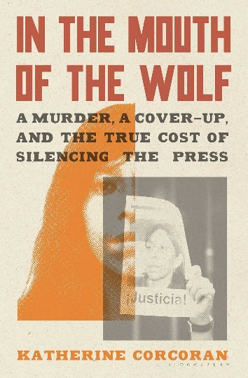

Enlarge this image

*Bloomsbury Publishing*

In 2011, corrupt Mexican police and cartel members murdered Javier Sicilia's son and six others. In the aftermath, Sicilia — a journalist for Proceso magazine — published an open letter headlined "[Estamos Hasta la Madre](https://www.uv.mx/blogs/lectores/files/2011/04/cartaAbierta.pdf)" (We've had it up to here), launched a peace initiative and demanded government reform.

A year later, Regina Martinez, another Proceso journalist, was[beaten and strangled in her apartment](https://www.npr.org/2012/05/09/152337896/mexican-crime-reporters-risk-becoming-the-story).

Since 2000, [150 Mexican journalists have been killed](https://rsf.org/en/country/mexico), according to Reporters Without Borders. [Hundreds of thousands](https://www.wola.org/analysis/mexico-disappeared-and-missing-people/) of Mexican women and students disappeared during this time of intense turmoil in Mexico. This year, on the 11th anniversary of his son's murder, Sicilia lamented the lack of reform, writing that "[there's nothing left to say](https://www.proceso.com.mx/nacional/2022/3/28/ya-no-tenemos-nada-que-decir-el-estado-nos-traiciono-javier-sicilia-283270.html)."

But Katherine Corcoran has plenty to say, in her epic new book In the Mouth of the Wolf, a deeply reported and riveting account of Regina Martinez's murder.

To some,what Corcoran has uncovered shows how broken Mexican society is. But paradoxically, her reporting also reveals the best of Mexico — the courage and integrity of Mexican journalists, the resilience of citizens determined to find justice where the rule of law is itself hostage, and the love of family and country that unifies the Mexican people.

Martinez, who was born in 1963, was a veteran journalist and crime reporter for[Proceso](https://www.proceso.com.mx/), known for investigative journalism and its focus on politics and social issues. Direct, unflinching, outspoken — these are the traits that led to Martinez's murder for reporting on government corruption, human rights abuses, and the relationships between government and organized crime in the Mexican state of Veracruz.

The Veracruz government quickly claimed to resolve the murder with the arrest of a suspect, but the accused said his confession was coerced. Martinez's colleagues were [deeply skeptical](https://www.sinembargo.mx/06-05-2012/225442) of the government's handling of the case — which discountedher reporting as a motive for her murder and included testimony from dead eyewitnesses — and conducted an[independent investigation](https://elefantmedia.b-cdn.net/aswftt/ASWFTT_report01_march15_digital.pdf?mtime=20210315095406&focal=none).

Corcoran, a former Mexico City bureau chief for The Associated Press, traveled throughout Mexico while researching In the Mouth of the Wolf. She met with reporters that Martinez had mentored and followed various leads at great personal risk to identify Martinez's killer.

In gripping detail, the book documents the existential gaslight that passes for institutional credibility in Mexico and the U.S.: the serial cover-ups, criminal bureaucrats, red tape, torture, the money trail to U.S. banks and race tracks, the deadly sweet spot where the private sector, the state and organized crime intersect.

Mexican journalists work in a setting of rampant criminal violence and impunity coupled with the active subversion of civic institutions, according to a[joint report](https://elefantmedia.b-cdn.net/aswftt/ASWFTT_report01_march15_digital.pdf?mtime=20210315095406&focal=none) from the Committee to Protect Journalists, Reporters Without Borders and Free Press Unlimited.

Corcoran's reporting illuminates these statistics, revealing details of perfidy and courage, such as the time a reporter woke up in his Mexico City hotel room to find that overnight, a mysterious box of chocolates had been placed in the dresser drawer where he kept his reporter notepads. (He kept reporting and ate the chocolates.)

In the end, Corcoran's closing thesis on the who, what and why of Martinez's murder not only makes sense, it also highlights threats to freedom of the press in the U.S. and hints at American complicity in Mexico's crisis.

The latter includes American intervention in Mexican domestic affairs, the laundering capacity of American banks, the sales reports of American gun exports to Mexico and the U.S. consumer market for illegal drugs. Corcoran's next book should follow the money north.

# Sri Lankan author Shehan Karunatilaka wins 2022 Booker Prize

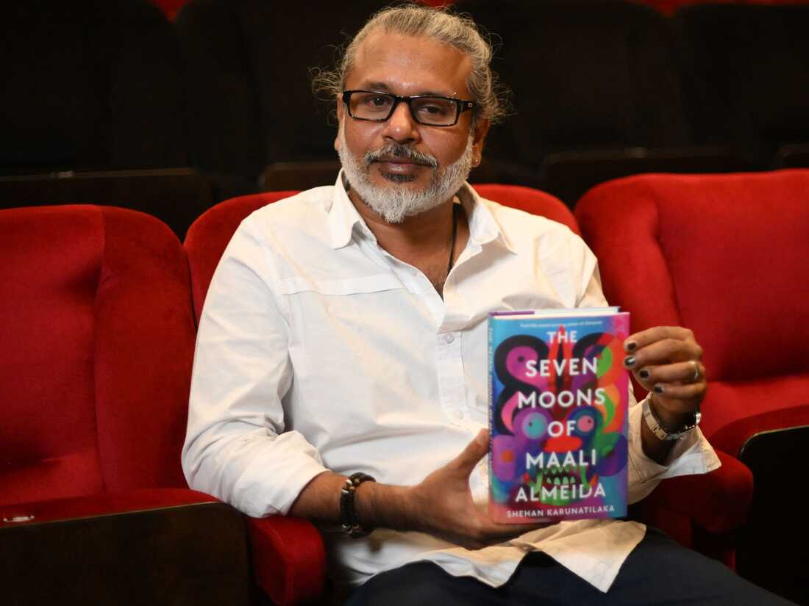

Sri Lankan author Shehan Karunatilaka holds his book *The Seven Moons of Maali Almeida* at the Shaw Theatre in London on Oct. 14. On Monday, his novel won the 2022 Booker Prize.

*Daniel Leal/AFP via Getty Images*

The 2022 Booker Prize was given to The Seven Moons of Maali Almeida, written by Sri Lanka's Shehan Karunatilaka. The annual award, which was given Monday evening in London, is for a work of fiction written in English and published in the U.K. and Ireland.

The panel of judges hailed Karunatilaka's novel as "a searing, mordantly funny satire set amid the murderous mayhem of a Sri Lanka beset by civil war."

Karunatilaka is one of Sri Lanka's foremost authors; his first novel, 2011's Chinaman, was quickly marked as the arrival of a significant literary force. His work has also been published in Rolling Stone, GQ and National Geographic.

The five other [shortlisted nominees](https://www.npr.org/2022/09/06/1121258250/booker-prize-shortlist-2022) for the 2022 Booker Prize were [Glory](https://www.npr.org/2022/03/10/1085677329/glory-nods-to-orwell-as-animals-explore-survival-under-a-corrupt-government), by NoViolet Bulawayo of Zimbabwe; [The Trees](https://www.npr.org/2021/09/18/1038533170/percival-everetts-novel-the-trees-parses-through-races-part-in-a-southern-murder), by American novelist Percival Everett; Treacle Walker, by English novelist Alan Garner; [Small Things Like These](https://www.npr.org/2021/12/22/1065780684/claire-keegan-book-small-things-like-these-magdalene-laundries), by Irish author Claire Keegan; and [Oh William!](https://www.npr.org/2021/10/19/1047327180/author-elizabeth-strouts-oh-william-composer-pens-remembrance-songs), by American novelist Elizabeth Strout.

The Booker Prize includes a £50,000 (over $56,000) award to the winner, as well as £2,500 (about $2800) awarded to each of the six shortlisted authors.

The organization also gives a separate honor, called the International Booker Prize, to a work of fiction translated into English. The [2022 award](https://www.vermontpublic.org/vpr-news/2022-06-08/vermonter-daisy-rockwell-wins-the-international-booker-prize-for-her-translation-of-tomb-of-sand) was made in June to the novel Tomb of Sand by the Indian novelist Geetanjali Shree, which was translated into English by Daisy Rockwell.

# She wrote a Bigfoot book for kids. It was no small feat

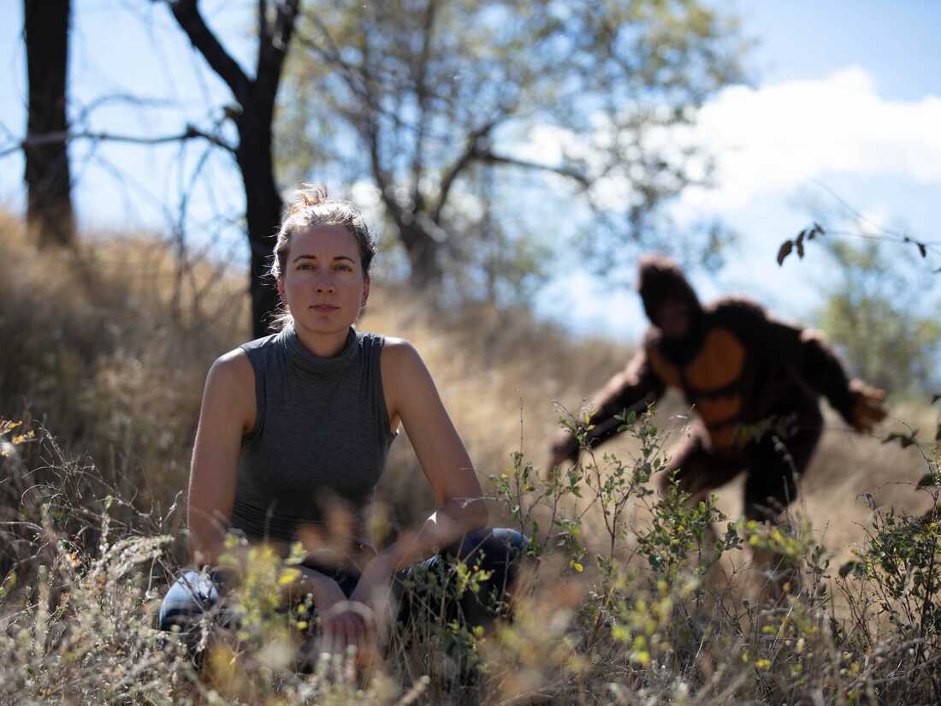

Despite her investigative efforts, Laura Krantz (left) has never seen a Sasquatch. That doesn't mean Sasquatch (right) hasn't seen her.

*Jake Holschuh/Laura Krantz*

For decades people have grappled with the myth and mystery of Bigfoot, with some seeking their own explanations through grainy video footage, campfire tales and wilderness expeditions.

Journalist Laura Krantz takes a more scientific approach. She's the host of the [Wild Thing podcast](https://www.foxtopus.ink/wildthing), which examines the relationship between science and society and its first season focuses entirely on the legendary beast.

Krantz traces her own interest in Sasquatch to the discovery of a long-lost relative: her grandfather's cousin [Grover Krantz](https://www.smithsonianmag.com/smithsonian-institution/scientist-grover-krantz-risked-it-all-chasing-bigfoot-180970676/), an anthropology professor who firmly believed in the existence of Bigfoot — a notable outlier in his profession.

"And so for me, it was sort of this question: How can you hold on to being a scientist and also onto this idea of Bigfoot at the same time?" Krantz recalls. "And that's really what kicked off this exploration. Like, what kind of evidence do we have? What kind of information is out there? Does anything stand up to rigorous scientific exploration and investigation?"

### Taking a scientific approach to the Bigfoot myth

Those are some of the questions Krantz sets out to answer in her new book, The Search for Sasquatch, which is aimed at middle-grade readers (between eight and 12 years old) and rooted in the language of science.

Krantz, who used to work for NPR, tells Morning Edition's A Martínez that the book offers an opportunity to take a mythical topic with a lot of lore behind it "and see if there's anything real to it." That means investigating things like, if Bigfoot exists, where it would live on the evolutionary tree (including relative to humans) and what its DNA would look like.

For her research, Krantz traveled to "Sasquatch hot spots" in and beyond the Pacific Northwest, including 10-foot-wide so-called Bigfoot nests in Washington state. She also interviewed wildlife experts and dug into DNA analysis.

"I approach this from the standpoint of: Bigfoot is a flesh and blood creature, the same as anything else on this Earth. It's not magical. It doesn't have superpowers," she adds. "And what I'm kind of hoping to encourage the readers to do, is say, 'OK, this is a really interesting idea. How can we look at this logically? How can we look at this through the lens of science?' "

There could be some logical explanations for even the most magical of Bigfoot's purported traits, Krantz says. For example, some devotees say Bigfoot vanishes — but she doesn't necessarily think that means he can turn invisible. Perhaps he's covered with so many twigs and leaves and hairs that if he stands extremely still, he's impossible to see.

Still, Krantz did hear some anecdotes that she has a harder time rationalizing. She spoke to scientists, wildlife biologists, hunters and avid outdoorspeople who spent lots of time in the woods and were familiar with the environment, yet "had an experience so bizarre that they really couldn't figure out another explanation." One such story made the hair on the back of Krantz's neck stand up when she heard it (she's avoiding spoilers, since it's in the book).

Enlarge this image

The Search for Sasquatch takes a journalistic and scientific approach to the decades-old question: Is Bigfoot out there?

*/Abrams Books for Young Readers*

Beyond the question of Bigfoot's existence, Krantz also wants to know why people are so fascinated with the creature. She offers two main takeaways from her reporting.

### Why is Bigfoot still a draw for curious minds?

"I think for some people it's the idea that the world is still wild enough and untamed and unpaved and unexplored that something like Bigfoot could be out there," she says. "I think we want that sense of mystery and that feeling that there's still things to find out there, because if we already know everything, then well, what's the fun in that?... I think, too, there's a sort of recognition that we need to preserve these wild spaces. It's almost an environmental mandate, a desire to preserve the sorts of places that Bigfoot could exist in, even if Bigfoot doesn't really exist."

Krantz is hopeful that her book will get readers excited about having outdoor adventures of their own, from going on hikes to exploring nature to trying to "lure a Sasquatch into their own campsite."

And while she believes the intrigue and folklore surrounding Bigfoot will draw young readers into the book, she also hopes its approach will help teach them how to make sense of the deluge of information they deal with in everyday life, whether that's from peers, through news headlines or on social media. In other words: Explore possibilities and ask questions, but stay grounded in the facts.

"Part of this is trying to help kids maybe be a little bit more scientifically literate, be a little bit more critical in their thinking about these kinds of stories and yet still realize that they can have fun with it and want to believe and have a good time with it," Krantz says. "I think the phrase is, be open-minded without your brains falling out."

The audio for this story was produced by Shelby Hawkins and edited by Reena Advani.

# Celeste Ng makes the case for art as a weapon against oppression in her new novel

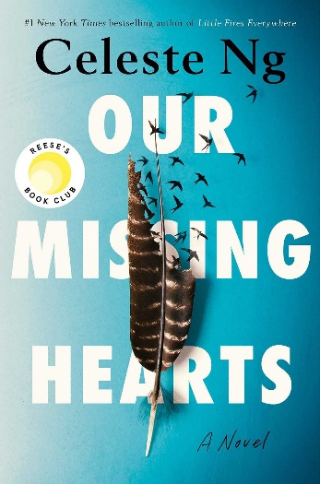

Enlarge this image

*Penguin Press*

Celeste Ng's Our Missing Hearts is not exactly dystopian or alternate history, as many events described in her latest novel have in fact happened, or are thinly disguised versions of real-life tragedies.

"The Crisis," for example, is a worldwide economic breakdown allegedly caused by China's market manipulation, and is clearly a fictional stand-in for the pandemic. Existential threats to certain individuals or groups — a common trope in dystopian novels — are already a part of U.S. history, such as slavery, discrimination against Asians, and forced assimilation of Indigenous children. Other problems mentioned in the novel are ongoing: police brutality, racial violence and economic inequality.

Our Missing Hearts is saddled by grief. But it is also propelled by hope, less a grim prognosis of the future than an impassioned call for a full reckoning with the past.

In this sense, Ng's narrative does borrow one important element from dystopian fiction — the idea of memory erasure, imposed by a repressive regime and borne by individuals cut off from their cultural legacy.

The book begins in media res, from 12-year-old Bird Gardner's point-of-view. As befitting his name, the boy embodies Emily Dickinson's vision of[hope](https://www.poetryfoundation.org/poems/42889/hope-is-the-thing-with-feathers-314) as "the thing with feathers - / That perches in the soul - / And sings the tune without the words." Bird carries, literally and figuratively, the novel's "seedling" — its narrative arc and moral weight.

As in a fairy tale, Bird must first embark on a harrowing quest to find out the truth about his mother, Margaret Miu, an Asian American poet who has apparently abandoned her family.

Bird's best friend Sadie thinks Margaret is the leader of an underground resistance movement, which manifests itself in frequent, startling acts: intersections painted blood-red; giant red hearts, made by yarns and entwined with ghostly dolls, which sway from trees in parks.

Bird's father, Ethan, forbids his son to mention Margaret's name to anyone. Subject to state surveillance, Ethan and Bird must conform to the safe code of conduct as prescribed by PACT (The Preserving American Culture and Traditions Act).

Thanks to its seamless structure, Our Missing Hearts resembles a box of myths transmuting into fresh, symbiotic insights when converged. Bird's quest, a bus trip from Cambridge, Mass., to New York City, evokes the Greek myth of Orpheus, in which the hero must travel to the underworld to find his beloved. It also echoes "The Boy Who Drew Cats," a Japanese folktale about a boy who, by drawing cats on the wall of a monster's lair and "keeping to the small," succeeds in killing the monster, a giant rat.

Ng's clever juxtaposition of the Orpheus myth (a beloved's eternal absence transformed into art) with the Japanese cat myth (an artist's triumph over evil) sums up the tragedy/hope duality at the heart of Our Missing Hearts. As well, her mesmerizing storytelling "keeps to the small," by conjuring finely drawn Asian Americans characters and dismantling their stereotypical portrayal as conformists or lacking in emotional complexity.

The Chinese character for Margaret's surname, Miu, contains the ideographic roots for "beast" and "domesticated cat." The more Bird learns about his mother, the more he realizes that Margaret is neither ideologically driven nor traditionally homebound — but someone awakened to systemic injustice by testifying to her own, and others' sufferings.

The novel affirms Ng's conviction that aesthetic means can be employed effectively to resist oppression. For example, the author describes how the poet Anna Akhmatova memorized her poetry and transmitted it orally to trusted friends to evade Stalin's censorship.

Similarly, Margaret meticulously records stories told by parents whose children have been taken from them under PACT. Performance art, as a form of nonviolent protest, is another example of "keeping to the small." While this type of protest takes place in public, passersby are affected privately, "forcing them to take note, [unsettling] them days and weeks later, knotting a tangle in their chest."

Ng suggests that these peaceful but thought-provoking measures in the long run may be more far-reaching and cost-effective than mass rallies that disrupt daily activities and compromise public safety.

Finally, while Ng's novel represents a critique of late capitalist, culturally white America, its inspirations seem to be drawn from Václav Havel's celebrated 1978 essay, "[The Power of the Powerless](https://www.nonviolent-conflict.org/wp-content/uploads/1979/01/the-power-of-the-powerless.pdf)," on the ways that an individual can undermine the machinery of a repressive state:

... [I]n its most original and broadest sense, living within the truth covers a vast territory whose outer limits are vague and difficult to map, a territory full of modest expressions of human volition .... Most of these expressions remain elementary revolts against manipulation: you simply straighten your backbone and live in greater dignity as an individual.

"A territory full of modest expressions of human volition" is also the profound, elegant message of Our Missing Hearts. Celeste Ng's latest work depicts life-like Asian Americans who hope to make peace with the past and change the future by taking small, self-assured steps.

Thúy Đinh is a freelance critic and literary translator. Her work can be found at [thuydinhwriter.com](https://thuydinhwriter.com/). She tweets [@ThuyTBDinh.](https://twitter.com/ThuyTBDinh)

# Kate Beaton's new graphic memoir is about the dark type of job you take for money

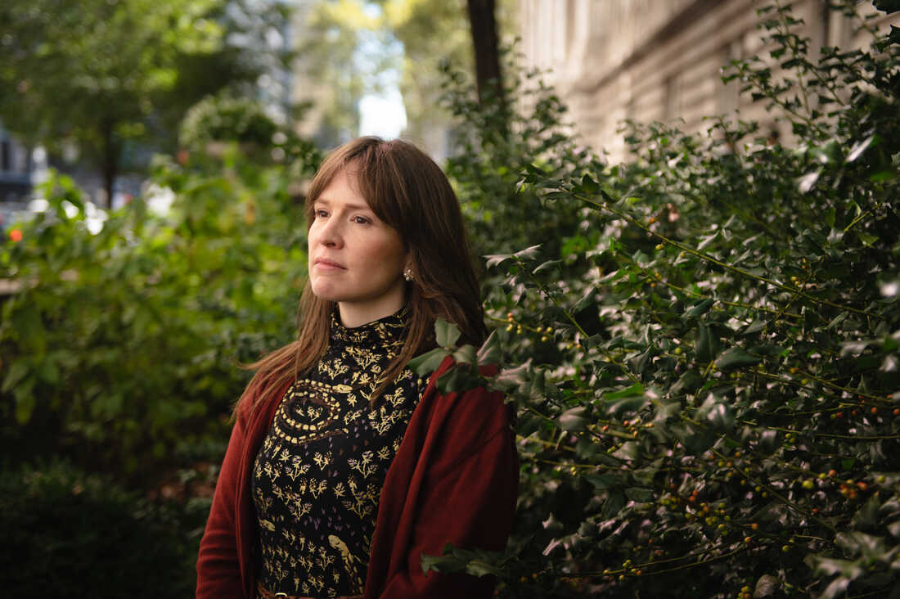

Kate Beaton's new graphic memoir, *Ducks: Two Years in the Oil Sands,*focuses on her time working at the oil sands of Fort McMurray, in Alberta, Canada.

*Kholood Eid for NPR*

There are jobs you take because you might find them fulfilling, or they're a stepping stone to a career you see for yourself. And then there are jobs you take for the money. The new book, Ducks: Two Years in the Oil Sands, is about the latter.

It's from Kate Beaton, author of the popular webcomic [Hark! A Vagrant](http://www.harkavagrant.com/), as well as a number of children's books. But while her comic is known for its funny and exuberant takes on historical figures, with Ducks, Beaton uses her talents to examine her own life. Specifically the years she spent working at the oil sands of Fort McMurray, in Alberta, Canada.

"I didn't have a good time there," said Beaton. "I lived in the camps, and that was hard. That was very hard. I was a young woman, and by myself. I was harassed all the time."

The book starts over on the east coast, on Cape Breton Island in Nova Scotia, where Beaton is from. It's a beautiful place that's long been economically disadvantaged. For a while it was home to various industries – steel, coal, fishing. And then it wasn't. So the island started sending its people out to wherever jobs were.

This idea – that you *have* to leave home to make a life for yourself – ingrained itself into the culture of Cape Breton. And the book opens with Beaton talking us through how.

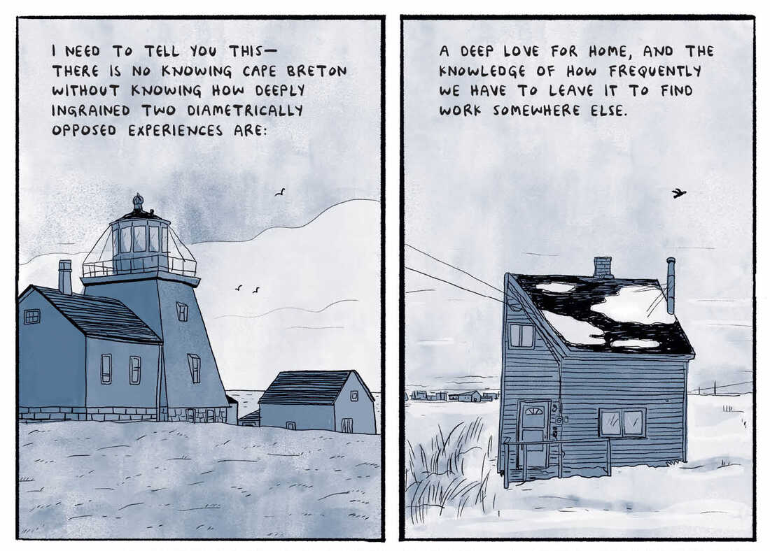

*Courtesy of Drawn & Quarterly*

"This push and pull defines us," a cartoon Beaton says in the opening. "It's all over our music, our literature, and our understanding of our place in the world. To have not is a mental state, as well as an economic one."

Her parents try to convince her to go into teaching or nursing, but she heads west, to the oil sands of Fort McMurray. It's an oil boomtown populated mostly by men who are, similarly, away from their homes and families. It makes it all the easier for them to fall into the traps of boomtowns — drugs, alcohol, loneliness.

The book follows Beaton as she deals with her own sense of isolation, while having to put up with constant sexism and misogyny. Men spread rumors about hooking up with her. They talk about her body at work openly. They walk into her bedroom "by accident."

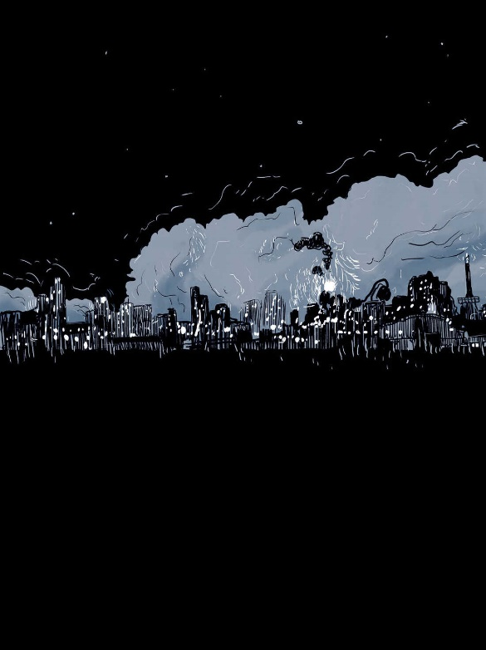

*Courtesy of Drawn & Quarterly*

But Beaton depicts small moments of tenderness too, from people looking out for her in their own ways. And there are the people who populate the city and are simply putting their heads down and providing for their families, just trying to get by.

Chris Turner, author of the book [The Patch: The People, Pipelines, and Politics of the Oil Sands](https://www.simonandschuster.com/books/The-Patch/Chris-Turner/9781501115103) said the book avoids caricaturizing the town. Where other depictions at the time portrayed Fort McMurray as a lawless Wild West, Beaton's treats the workers with care and grace. That took a lot of courage, Turner said, "given that a lot of these guys, if you wanted to be damning about it, were enabling some of the culture she ran into."

Throughout Ducks, Beaton draws these huge landscapes. There'll be a big beautiful sky juxtaposed with seemingly equally huge and (and just as imposing) machinery on the ground. It's a stark reminder of what the oil industry is doing to the land. Land that was previously occupied by someone else.

There's a scene late in the book when an increasingly tired Beaton watches [this interview](https://www.youtube.com/watch?v=kG2sJAn47QI&t=310s) with Celina Harpe. a Cree elder talking about the impacts the oil companies have had on their community. "Everything's ruined, our lives around our lands are ruined, our water, the air, everything," Harpe says. "At the cost of our lives — as long as they get their money. They don't care how many of us they kill off. That's the way I feel."

The moment coalesces the books themes of complicity and complicity and agency and power. Beaton said when the companies first came in to the area, the First Nations people in the area weren't given much say. And now they are [tangled up economically in these industries](https://www.baltimoresun.com/health/la-fg-canada-oilsands-cancer-20131021-story.html) [that are polluting their land](https://www.theguardian.com/environment/ng-interactive/2015/may/28/carbon-bomb-canada-tar-sands-fort-mckay-town-sold-itself), [and leaving them with higher rates of cancer](https://www.theglobeandmail.com/news/alberta/where-oil-and-water-mix-oil-sands-development-leaves-fort-mckays-indigenous-communitytorn/article27151333/).

"But what choice did they have but to be involved, or be completely crushed?" said Beaton.

The book is called Ducks after in [incident in 2008](https://www.nytimes.com/2008/05/01/business/worldbusiness/01sands.html) when a couple hundred migrating ducks landed in Canadian oil sludge and died. In the grander scheme of ecological disasters, it wasn't horrible. But the ducks were photogenic, and it became front page news. People started speaking out against the oil companies. Fines were issued.

When you listen to Beaton talk about her time in the oil sands, it's clear she's weighted down by everything that didn't make front page news, from the First Nations communities wrecked by the oil mining, to the decisions her fellow workers are forced to make when working the oil sands is one of the few options for a decent wage.

Beaton said people constantly try and make the oil sands about one thing. To refine it down to one issue. Ducks shows why that's impossible. "Life isn't that way," she said.

# Fantasy grifter 'Kalyna the Soothsayer' will charm her way into your heart

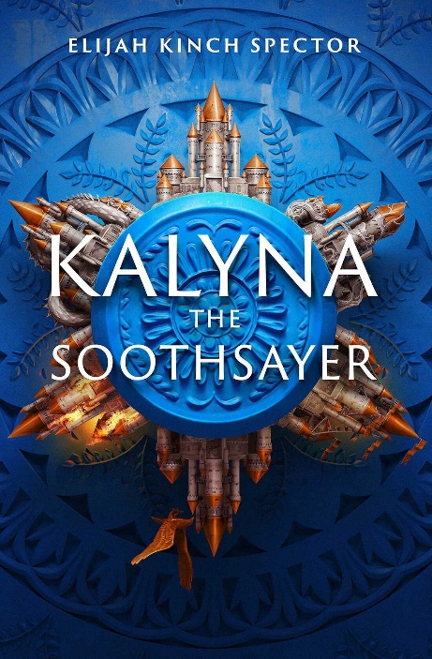

Enlarge this image

*Erewhon*

The fantasy archetype of the soothsayer is often a supporting character, trotted out or journeyed to for a crucial yet standalone scene in which she provides some context or clue to the hero about how everything will turn out. Then she usually retreats into her remote hideout, never to be seen again — at least not until the next protagonist requires a glimpse into the future.

But in Elijah Kinch Spector's delightful debut fantasy adventure Kalyna the Soothsayer, not only is the fortuneteller the unlikely hero, but she's also a shameless fake.

The eponymous Kalyna Aljosanovna is descended from a proud clan of future-seers, but their hereditary gift never took root in her. The fact that her bloodline ends with her hasn't stopped her from carrying on the family business, using a network of paid informants and her own shrewd observations of human behavior to make just-accurate-enough prognostications about her customers' upcoming fortunes.

It helps that she, ailing father Aljosa and her nasty grandmother are nomads, used to fleeing in the middle of the night and/or being run out of town by suspicious locals.

But not even Kalyna can foresee a political plot in which she's kidnapped so that she can advise the louche Prince Friedhelm of Rotfelsen, who will do anything to avoid his royal birthright. Kalyna is his "Eleventh Recourse," just as disposable as the 10 people before her if she fails to predict a future of continued debauchery.

While Kalyna is no stranger to telling someone what he wants to hear, the stakes are heightened when they involve the fate of an entire kingdom, not to mention the supposed end of the world.

The best lies contain a bit of truth. But in Kalyna's case she must *not* reveal what her father sees — the entire country crumbling in just a few months — if she wants to save her own skin.

Kalyna possesses a frenetic energy, recklessly jumping on hunches if they turn a sword or gun away from her and toward another suspect. Her desperate psychic improv stokes the already fractious atmosphere at Rotfelsen's royal court, making for a mad romp, despite a slow start.

Kalyna's story doesn't really get going until literally the wheels are turning — that is, as she's spirited away from an encampment in Masovska by the spymaster of neighboring Rotfelsen.

Despite crossing borders, they aren't actually leaving the country. The two realms are part of the Tetrarchic Experiment, which has sought to unite four very different kingdoms ("cold and superstitious Masovska; jagged and paranoid Rotfelsen; precarious and discrete Quruscan; fertile and motley Skydašiai") in tentative coexistence.

It's a keen setting for a tale of court intrigue and pretenders double-crossing one another. As Kalyna reflects, you cannot con someone whose way of thinking you cannot understand. Tetrarchia's citizens learn one another's languages (if only out of obligation or convenience), but each quarter retains its own nationalist pride and suspicion of outsiders.

And then you have someone like Kalyna, who looks like she's from both everywhere and nowhere — a quality that's useful for shifting between factions, but also a nasty hurdle to gaining the trust of the more xenophobic Rots.

Rotfelsen's court is a microcosm of the Tetarchia's tension, with four color-coded armies constantly at one another's throats: The Yellows, loyal to Prince Friedhelm; the Purples, who follow the dangerous court philosopher; the Reds, split between king and queen; and the Greens, Rotfelsen's actual army.

Kalyna aptly describes them as resembling confetti, strewn about in each another's business. Rotfelsen operates on an endless array of feasts and balls, except that each party is more of an excuse for attempted poisonings and dishonorable duels.

The tricky narrative style challenges the reader's expectations of tidy chapters, instead laying out the action in vividly-titled scenes ("I Concoct a Dangerous Plan," "A Clear Case of Assassination"), each not unlike a tarot card illustrated with a single visual or self-contained narrative.

Jumping back and forward in time as she relates her misadventures, Kalyna shuffles the metaphorical tarot deck for an extended reading of the past, present and (but of course) the future. Just like her soothsaying, what initially appears to be a gimmick takes on real heft as the story unfolds.

Even with all the back-stabbing (and front-stabbing, and sharpshooting), Spector cunningly puts this puny mortal hand-wringing about the future into stark perspective with reminders of what a nascent, dysfunctional country the Tetrarchic Experiment is.

Like any encounter with a fortuneteller, it's best to put your trust in Kalyna's hands and let her build a story around the two of you. Parts of it will speak to your own specific fears and desires; other aspects will be entertaining fictions, until you discover the devastating shard of truth within. And even if you know from the start that Kalyna is a swindler, she'll still surprise you (and even herself) by seeing something that no one else can.

Natalie Zutter is a Brooklyn-based playwright and pop culture critic whose work has appeared on Tor.com, Den of Geek, Paste Magazine and elsewhere. Find her on Twitter [@nataliezutter](https://twitter.com/nataliezutter).

# Here are the finalists for the 2022 National Book Awards

# Some of the books on the short list for the National Book Award.

# *Meghan Collins Sullivan/NPR*

The finalists for this year's National Book Awards have been announced.

Among the nominees are author Yoko Tawada and translator Margaret Mistutani, who won the 2018 National Book Award for translated literature. Three other nominees — Gayl Jones, Scholastique Mukasonga and Pulitzer-winning poet Sharon Olds – have been finalists before.

In contrast, three of the five finalists for fiction have been nominated for their debut novels: Sarah Tess Gunty, Sarah Thankam Mathews and Alejandro Varela.

And all five of the finalists for young people's literature are being honored by the National Book Awards for the first time, including [Tommie Smith](https://www.npr.org/sections/codeswitch/2018/10/16/657548752/those-raised-fists-still-resonate-50-years-later), the U.S. athlete who raised a fist in protest against racial discrimination at the 1968 Summer Olympics in Mexico.

The winners will be announced on Nov. 16 in New York City. Two lifetime achievement awards will also be presented, to Maus author Art Spiegelman and Tracie D. Hall, the first African American woman to serve as the American Library Association's executive director.

Winners of a National Book Award receive $10,000. The full list of finalists is below.

### Fiction

**Tess Gunty**, The Rabbit Hutch

**Gayl Jones**, The Birdcatcher

**Jamil Jan Kochai**, The Haunting of Hajji Hotak and Other Stories

**Sarah Thankam Mathews**, All This Could Be Different

**Alejandro Varela**, The Town of Babylon

### Nonfiction

**Meghan O'Rourke**, The Invisible Kingdom: Reimagining Chronic Illness

**Imani Perry**, South to America: A Journey Below the Mason-Dixon to Understand the Soul of a Nation

**David Quammen**, Breathless: The Scientific Race to Defeat a Deadly Virus

**Ingrid Rojas Contreras**, The Man Who Could Move Clouds: A Memoir

**Robert Samuels and Toluse Olorunnipa**, His Name Is George Floyd: One Man's Life and the Struggle for Racial Justice

### Poetry

**Allison Adelle Hedge Coke**, Look at This Blue

**John Keene**, Punks: New & Selected Poems

**Sharon Olds**, Balladz

**Roger Reeves**, Best Barbarian

**Jenny Xie**, The Rupture Tense

### Translated Literature

**Jon Fosse**, A New Name: Septology VI-VII. Translated by **Damion Searls**

**Scholastique Mukasonga**, Kibogo. Translated by **Mark Polizzotti**

**Mónica Ojeda**, Jawbone. Translated by **Sarah Booker**

**Samanta Schweblin**, Seven Empty Houses. Translated by **Megan McDowell**

**Yoko Tawada**, Scattered All Over the Earth. Translated by **Margaret Mitsutani**

### Young People's Literature

**Kelly Barnhill**, The Ogress and the Orphans

**Sonora Reyes**, The Lesbiana's Guide to Catholic School

**Tommie Smith, Derrick Barnes and Dawud Anyabwile**, Victory. Stand!: Raising My Fist for Justice

**Sabaa Tahir**, All My Rage

**Lisa Yee**, Maizy Chen's Last Chance